**Exceptions**  
* We’ll start with exceptions because many of the methods that we’ll be using to read and write files actually require that exceptions are handled.  
* There’s 2 main approaches to dealing with errors when programming:  
1) **LBYL** => Look Before You Leap  
2) **EAFP** => Easier to Ask Forgiveness than Permission

* **In Java it’s more common to LBYL**.  
* **We’ve seen this a lot when we tested that an object is not null before we attempted to use it**.

* **EAFP is to go ahead and perform the operation, then respond to an exception if it goes wrong**.

* Trapping and handling exceptions is pretty simple. The code that may cause a problem is wrapped in a **TRY** and then a **CATCH** is used to deal with the exception.  
* Let’s see some examples.  
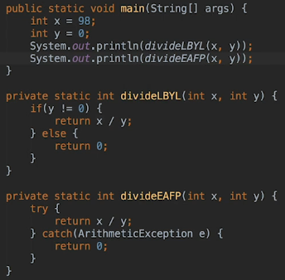   
* **ArithmeticException**  
* Each approach has its own advantages that are more suited to certain situations.  
* When using Java it’s more common to check first but sometimes it’s far easier to just try and see.  
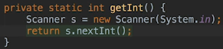  
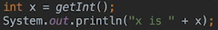  
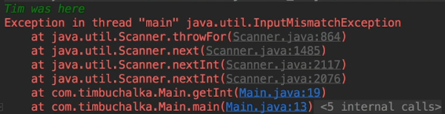

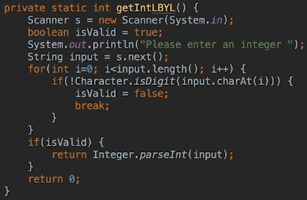  
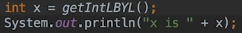  
* That’s quite a bit of code to confirm that the input was valid.  
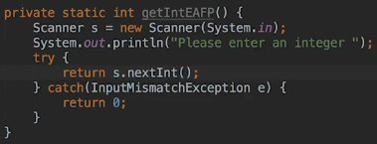  
* There’s less code here in this case and I think it’s a little bit more elegant as well because you can look at that very quickly and understand.  
* It really depends on what you’re trying to achieve whether you use LBYL or EAFP.  
* The LBYL can be better in some situations too, for example it wouldn’t really make sense to use a TRY CATCH block when checking that a key exists in a Map for example. In that scenario it’s probably a lot quicker to use the LBYL approach.

**Stack Trace and Call Stack**  
* What is an exception?  
* The Java documentation defines an exception as **an event which occurres during the execution of a program that disrupts the normal flow of program’s instructions**.  
* I guess that could be summarized more simply as **something went wrong somewhere**, which is possibly a more useful definition because it leads more naturally to 2 very important questions:  
1) **What went wrong**?  
2) **What can we do about it**?  
* Exception and RuntimeException are classes defined in java.lang and the different types of exceptions that can be called are subclasses of one of these two exceptions. So normally when catching an exception, you’d specify which subclass of exception to catch.  
* **We could just catch an exception but it’s a good idea to be more specific and catch the specific exception rather than just generalizing and doing sort of the catch-all catch so to speak**.  
* **The type of exception thrown answers the question what went wrong so that’s one good reason to use that**.  
* In our example we just returned 0 but to let the calling method know that there was a problem, we could **throw an exception**. That means passing the exception back to the calling method.

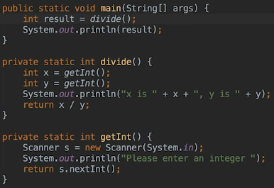  
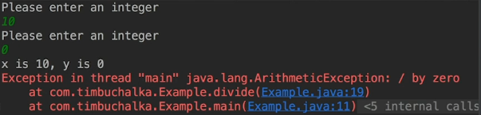  
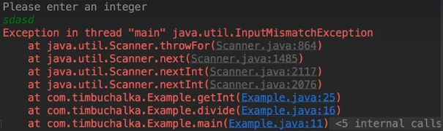  
* **ArithmeticException**  
* **InputMismatchException**  
* Java automatically prints a **STACK** **TRACE** which is showing the **CALL STACK**. The call stack is a list of all the method calls at any particular point in a program’s execution. In this case it’s all the method calls at the point where the program crashed.  
* **So each thread of execution has its own call stack and the thread is shown as the first line of the stack trace**.  
* **Every time a new method is called, it’s placed onto the stack and when a method returns, it’s then removed from the stack**.  
* **The best approach to make sense of these traces is generally to start at the BOTTOM and then work back up**.  
* This is the code that’s eventually throwing the exception from Scanner.java:  
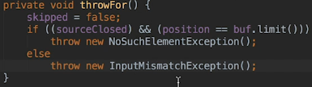  
* Exception class itself extends **Throwable, the Throwable constructor fills in the stack trace for the exception**.  
* When the exception itself is thrown, the Java Runtime then looks to see what can handle it. It does that by working back up the call stack. Each method on the stack gets the exception. If it doesn’t handle it, then the exception gets passed on to the previous method on the stack and so on. So the exception is set to propagate the call stack and it keeps getting passed to the calling methods until there’s 1 that actually can handle that exception.

* **It might make more sense to talk about propagatin down the call stack but stacks tend to be implemented growing downwards so we talked about going back up the stack**.  
* Eventually if nothing handles the exception then the main Java entry point just prints the stack trace and the Java Runtime terminates and that’s what actually happened here.

* **Exception objects are generally like this - the subclasses exist to provide more granularity so that code can check the different types of errors by catching the subclasses**.

* **InputMismatchException extends NoSuchElementException and exists purely to allow the exception handler to differentiate between the scanner running out of input and the input being invalid**.

**Catching and Throwing Exceptions**  
* If we press CTRL + D when being asked for the input, it’s going to send the ASCII EOT endo f transmission character to the program and that abruptly terminates any input.  
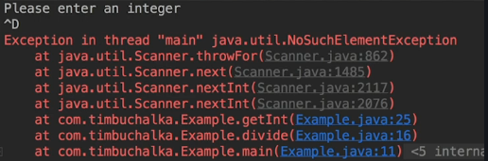  
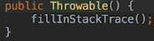  
* **Generally speaking there’s no point catching an exception unless your code can do something sensible with it as a result**.  
* **Sometimes you may wanna deal with the exception in some way even if you only want to propagate it**.  
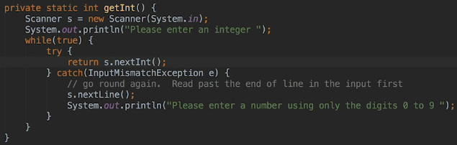  
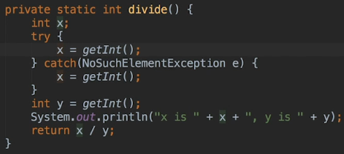  
* This is not a good exception handling, I just wanted to demonstrate **the importance of ensuring that exceptions are not raised in your exception handler code itself**. A catch block is there to catch one or more exceptions and as the name implies, exceptions are things that shouldn’t normally happen in the general scheme of things but we should guard against them in case they do.   
* **Keep them simple, to try to make sure they won’t cause more expcetions is really the rule here**.

* **It’s possible to nest a TRY CATCH block inside a CATCH block and sometimes it can be useful to do so but the best advice I can give you is to keep your CATCH blocks as simple as possible, the less code there is in the CATCH Block, the less chance there is another exception being thrown**.  
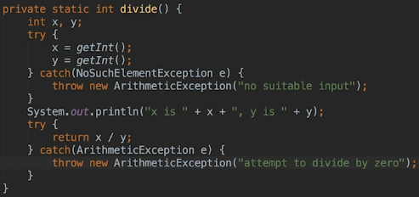  
* **We can also use the overloaded constructor that takes a string for the exception so that we can provide a bit more information on what actually happened. This is not really intended for the calling method but it’s useful in log files when a human has to work out what happened**.  
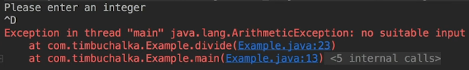  
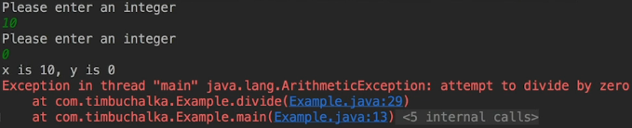  
* You can see that the stack traces are much simpler as well. That’s because the exception originated in the divide() method so Java doesn’t need to show any other methods that were being invoked.  
* Our code looks a bit clumsy and we’ll fix that up in the next video.

**Multi Catch Exceptions**  
* Let’s combine them:  
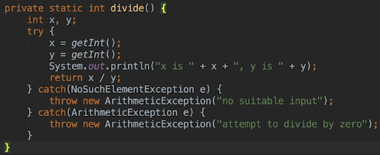  
* That’s a much neater way of doing things and it’s easier to read.  
* Starting with Java 7 it’s possible to handle multiple exceptions with a single CATCH block and I’ll show you that later, but here that wouldn’t have been appropriate because we want to place additional information in the exceptions before throwing them.

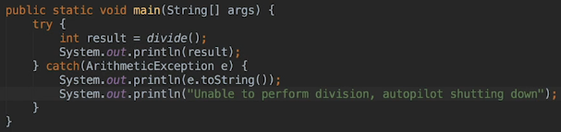  
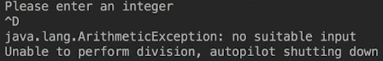  
* Later I’ll mention the differences between CHECKED and UNCHECKED exceptions.  
* This information about exceptions is enough to be getting on with I/O operations.  
* In a real application you would most likely remove the exception handling from divide() and move it to the main method and catch multiple exceptions:  
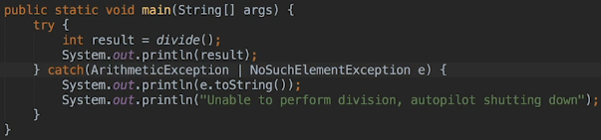  
* The **|** is a **bit-wise inclusive OR**. That’s the way to check for multiple exceptions.

**Introduction to I/O**  
* There’s several different approaches to Java I/O.  
* **Input involves reading data from a source**.  
* **Output involves writing data to some destination**.  
* Quite often the source and destination will be files on the computer’s disk drives but they can also be network connections and pipes as well as the computer’s keyboard and screen.  
* We’ve used the **Scanner** quite often to read input from the keyboard.  
* Strictly speaking we aren’t reading from the keyboard though, we’re actually reading from **System.in**.  
* In this section I also want to discuss dealing with disk files and directories. And the reason is that quite often you want to make a new directory to store your data or to present the user with a list of files to choose from and the file class provides methods for doing things like that.  
* There’s also quite a lot of jargon and theory involved in I/O but rather than spending a lot of time talking, I’m gonna introduce that as we work through various examples.  
* **There are some basics that I have to cover first though**:  
=> I/O can be performed using either BYTE or CHARACTER data and the methods used are pretty much the same, it’s just the actual classes used that will vary.  
=> So when reading and writing character data, the data is in a readable format and you can open the resulting files. But binary data on the other hand involves writing BYTEs that will not look very meaningful if you open the files in a normal text editor.  
=> Which type should you use really depends on what the data represents. And if you’re creating a report file to be imported into a spreadsheet, you probably choose a character stream and similarly character should probably be the correct type for writing XML or JSON data. But when storing program’s variables or classes, it may be more appropriate to use a binary format.

=> Another disctinction that needs to be made between sequential files and random access files.  
 => sequential access can be thought of as a stream of data that arrives at your program or is sent out from it in a defined order which each piece of data following in sequence.  
 => random access on the other hand only applies to files and allows you to jump within the file, retrieving or overriding any data in any location within that file that you choose. So this is more like a database program would work with some sort of index showing you where a particular record is within the file so that it can be read without having to be read through thousands of records first for example.  
=> I compared sequential data to a stream. In fact Java uses various stream objects to deal with it.

* Let’s use the Location and Main classes from our adventure game.  
* We’ll create a Locations class.  
* The original program uses a Map to store the locations and the approach we’re gonna take is creating a Locations class that implements that Map interface. This is going to basically allow us to place all the initialization code into the new class and not have to make any changes in our main method.  
* There are quite a few methods we need to implement for the Map<Integer, Location> interface:  
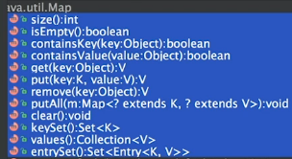  
* Let’s now create them:  
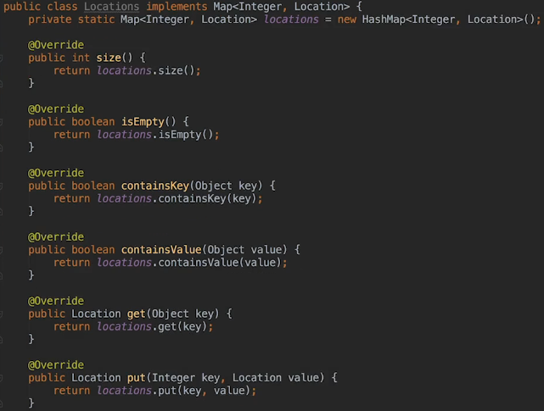

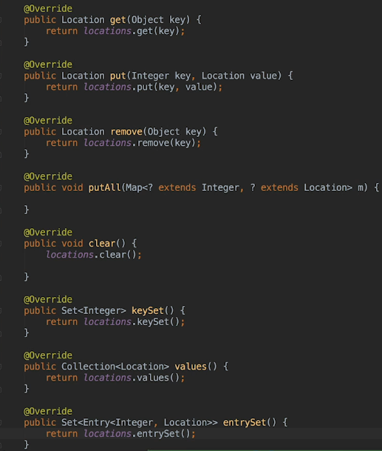  
* We’re not gonna do anything with the putAll() yet.  
* We’re using a HashMap to store the locations just like the Main class did and all the methods really just delegate to the corresponding methods of the HashMap.  
* **Now what we’ve created is a class which pretty much behaves just like a Map but which we can customize to load its contents from an external source, a disk file in this case**.  
* We can now swing over to the Main class and start replacing the locations Map with our new class.  
  
* I can remove this one line, it was just for showing problems with exposing the exits to an external class:  
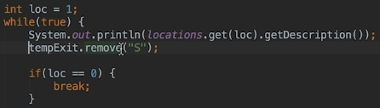  
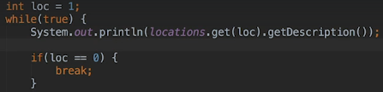  
* That’s really all the changes we need to make to Main.

* Now we’re gonna cut all the code that initializes the locations and paste that in the new Locations class. Line 21 - 47.  
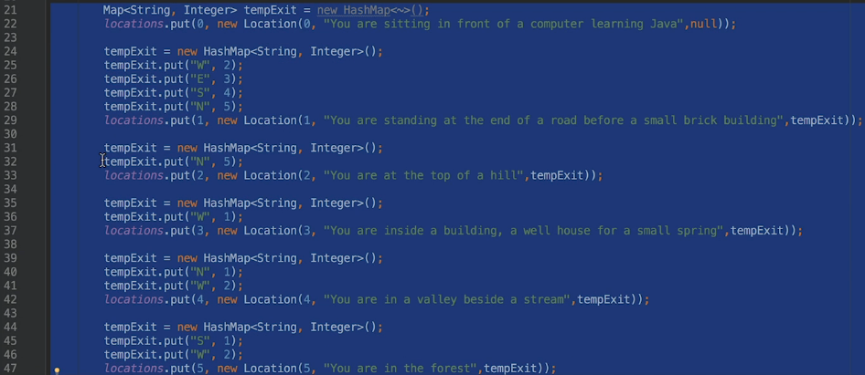  
* There really only needs to be 1 instance of the location data for the game, it doesn’t really make much sense to allow multiple instances of the Locations class to each have their own copy of the data.  
* There’s only 1 copy of static data that is shared amongst all class instances so here it makes sense to keep this location data static. And we can also use the static initialization block, it’s a good time to use one.  
* The static initialization block will be exectuted once - when the Locations class is loaded.  
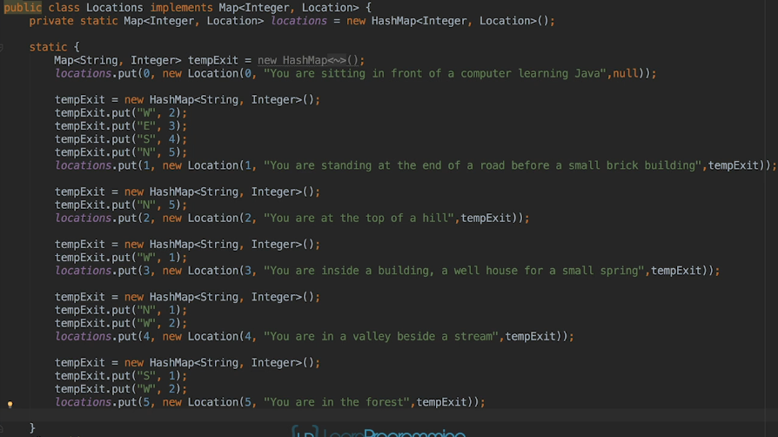  
* Now actually there’s no real reason to create more than one Locations object but as we can’t make the interface method static, we have to allow at least one instance to be created and of course once you do that, you can’t guarantee that someone else won’t create more than one of them.  
* Now there are ways to ensure that only a single instance of the class can be created, the Singleton Design Pattern is probably the simplest here but we’ll look at that later in the course.  
* But for this application making the data static and ensuring it’s only initialized once is actually fine. And using the static initialization block confirms that is the case.  
* If we run it we see that everything works fine so the Main class really doesn’t care that it’s now using our Locations class rather than a HashMap that it used to use because we’ve implemented the Map interface and all the required methods.

**Writing content - FileWriter class and Finally block**  
* The code in the Static Initialization Block is executed when the class is loaded and that means that all the data is gonna be available by the time we are able to execute any methods in the class.  
* As a result that means that we can create a main method to write out the locations and exits data to files.  
* One of the simplest ways to do that is using a FileWriter object.  
* **FileWriter**  
* **write()**  
* **close()**  
* **Failing to close streams can really cause problems such as resource leaks and locked files**.  
* **So if an output file is not closed then the data can become corrupted or the file remain locked so that no other process is able to use it**.  
* **It’s so important that Java 7 has introduced a much neatere way of dealing with streams to ensure that they’re correctly closed and we’ll be using that soon**.  
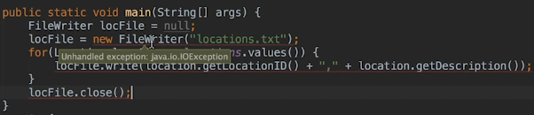  
* I mentioned that there are 2 categories of exceptions in Java: **CHECKED** and **UNCHECKED**. They work in the same way, the difference is that you can’t ignore CHECKED exceptions.  
* So **IOException** is a **CHECKED exception**.  
* If we try to catch it, that’s gonna fix it:  
* **e.printStackTrace()**  
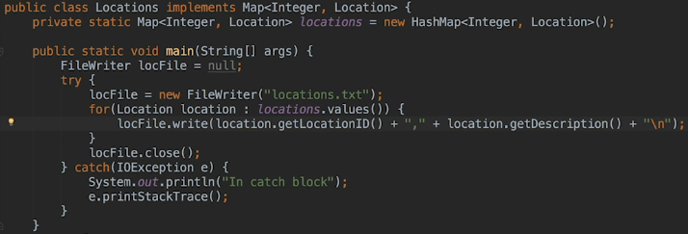  
* The locations.txt is created when we run it:  
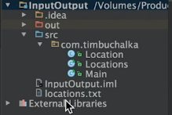

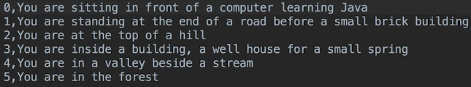  
* There is a problem with this code though and we have to add a little bit more complexity.  
* The problem is that the error in the loop that writes the data will cause the catch block to be entered, skipping over the call to the close() method. Which means the file isn’t gonna be closed if there is an error because it’s gonna skip straight to the catch block.  
* **FINALLY** block => if there is an exception raised in the TRY block, the code in the CATCH block for that exception will be executed but then regardless of what happened, the FINALLY block is also executed.  
* **TRY block needs to have either the CATCH block or the FINALLY block or both**.  
* **Having TRY + FINALLY only is quite common when dealing with I/O operations**.  
* Unfortunately close() itself throws an IOException:  
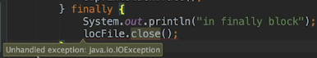  
* So we need to use the TRY CATCH again:  
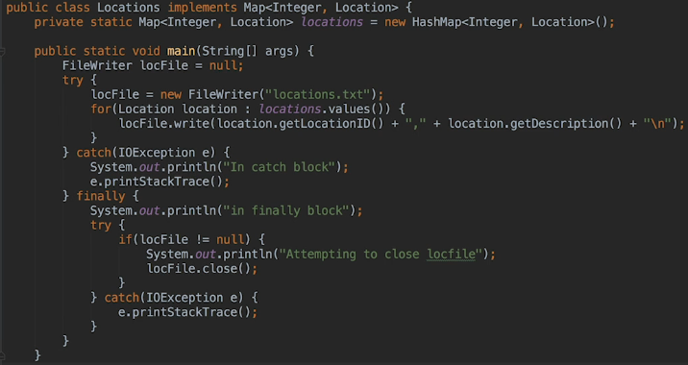  
* **Up until Java 7 the code in our Locations main class was pretty much the standard template for writing data to a stream and reading from a stream looks very similar to that**.   
* **Java 7 introduced an improvement that makes the code quite a bit neater**.  
* To test an exception, there’s quite a few ways to break IO code.   
=> On all 3 operating systems we could set locations.txt to read-only,   
=> on Linux + OSX we could change ownership to root,   
=> we can also specify an invalid path to a file,   
=> attempting to create a file on a disk drive that doesn’t exist on Windows or  
=> an invalid volume on Linux and also OSX.  
* The easiest way here though is to just delete the file we have written and create a directly with the same name before running the program and that’ll work on all 3 operating systems.

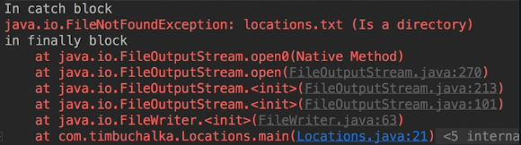  
* FileNotFoundException is a subclass of IOException and as a result it’s caught by our CATCH block.  
* You may see the message from the FINALLY block appear before the stack trace rather than after it, that’s really a result of the way that stack trace is generated.   
* The FINALLY block is executed after CATCH.  
* You may also send a message from the CATCH block amongst the stack trace but the program’s output will be printed in the order it happens but the stack trace will appear when it’s good and ready basically.  
* Here you can also see how useful it is to have a check for null because if we didn’t have it, we’d get a NullPointerException when trying to close the file.

**Try with Resources**  
* Why did I declare loc file at the start of the method instead of in the TRY block?  
* The reason we had to do that was that the TRY CATCH and FINALLY blocks introduce new scope so FileWriter declared inside a TRY block would not be available in the FINALLY block.  
* Now you might be looking at the code and thinking there’s quite a lot of code in that method to write our data and most of it is concerned with catching the exceptions that the FileWriter might throw.  
* I mentioned earlier that there really isn’t much point catching an exception unless you’re gonna do something about it or with it.  
* We’re now gonna use a very similar code to read the data back in and if the data can’t be loaded, then the rest of the game isn’t gonna work very well.  
* There’s really not much that can be done when a file can’t be opened so the best thing we can do here is to send the exception back to the calling program and alert the user to the error.  
* I said at the start that Java insists that we handle CHECKED exceptions, but there are 2 ways to handle them.  
**1) An alternative to catching them is to throw them back up the call stack**.  
* Obviously as this main method is the entry point for this part of the program, we don’t have any calling code that can handle the exception but the idea of throwing the exception instead of cataching it is very useful so we’re gonna have a look at how to do that.  
* Java documentation uses the term **catch or specify** for dealing with CHECKED exceptions. This means **the method must either catch the exception or specify that it throws it**.  
* **Often it’ll make more sense to specify rather than CATCH**.  
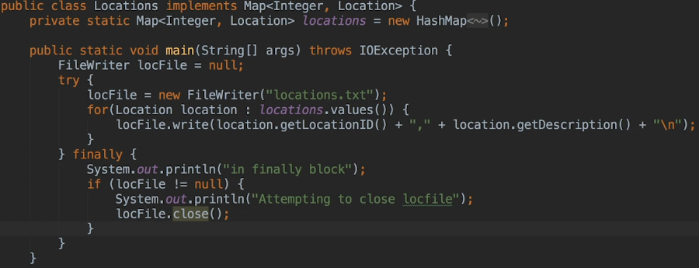  
* **throws** **IOException**.  
* We still do want that FINALLY block becauase we do want to test to see whether we’re closing it properly and if you’ve got a locFile reference, we do wanna close it so that’s why I’m leaving that FINALLY there.  
* **But in some scenarios with the way we’ve defined this now if you throw the IOException you can probably do without a TRY block altogether because you’re basically passing the responsibility for dealing with the IOException in this case to another method**.  
* But in this particular example we’re leaving the FINALLY clause in because we’re doing some processing just to check to see whether we can close the file.  
* **We can also break the code by deliberately throwing an exception to simulate something has gone wrong and that can be something that’s very usuful to be able to do**.  
* **Throwing your own exceptions can be a really useful technique while testing**.  
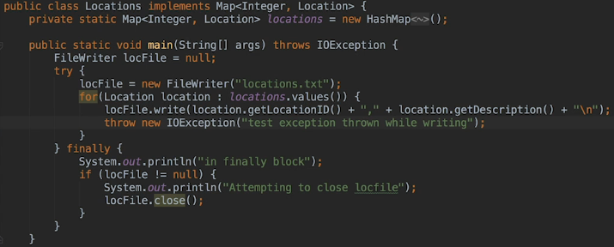  
* Make sure you delete it right after testing.  
* Now let’s also write the exits.  
* The old way before Java 7 would involve creating a new FileWriter object for the exits file, then writing the exits for each location in a loop, simialr to what we’ve done with the loop for locations.  
* Java 7 added a **TRY with resource** statement that makes everything a lot cleaner.  
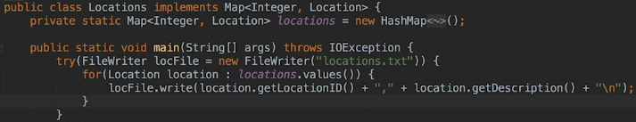

* You can see that the code is a lot neater and the FINALLY block has been removed because the good thing is with this **TRY with resources** it **automatically ensures that the FileWriter steam is closed whether the code executes normally or an exception occurs**.  
* This code does behave differently to the code we had previously - the documentation goes over the differences.  
* The differences occur if an exception is thrown when closing the stream in addition to an error in the TRY block. **In the TRY FINALLY example it would have been exception that was thrown by the close() method that was thrown up the stack**.

* **But writing the code this way with TRY with resources it causes the exception to be suppressed and the exception from the TRY block is the on that is thrown back up the stack** so that does make sense as it’s very likely that whatever problem occurred while opening or writing to the stream is probably of more interesting than the error closing the stream. The first error is probably the root cause of the error when closing if you think about it. So using TRY FINALLY, the first error would be hidden by the exception when closing the stream whereas this TRY with resources method ensures that the first error is the one being thrown back and that’s highly likely to be the error that you actually wanna be working with.  
* So it’s a subtle difference but definitely worth bearing in mind if you’re converting existing code to use TRY with resources.

**FileReader and Closeable**  
* You can still have a FINALLY block if you want but don’t use close() in it.  
* **Using the TRY with resources allows more than one resource to be specified and as a result we can create a second FileWriter to write the exits data out**.  
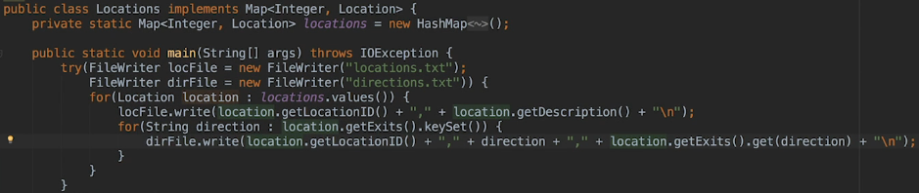  
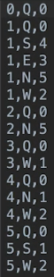  
* I should point out at this point that from a purely I/O point of view, there’s probably better ways to store the data for this game so writing it to a text file like this really isn’t very efficient.  
* But with that said, there can be advantages to storing data in a human-readable format.  
* **Now let’s look at reading data**.  
* Let’s now change the static initialization block, let’s comment all that code out.  
* **The process is very similar to writing**.  
* The main difference is that we need to pass the data into the individual strings and integers.

* **Let’s first see how it was done before Java 7**.  
* **FileReader**  
* **scanner.useDelimiter()**  
* **scanner.hasNextLine()**  
* **scanner.skip()**  
* **scanner.nextInt()**  
* **scanner.nextLine()**  
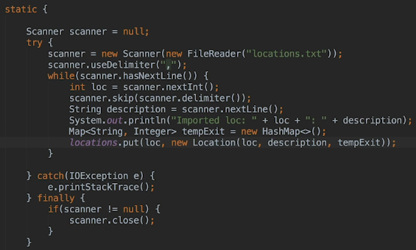  
* **I could have declared a new FileReader object variable and pass that to the scanner but you will find constructors chained together like this a lot when performing I/O operations in Java and in actual fact the classes are designed to work together in this fashion**.  
* Why is the FileReader object not closed despite me saying that closing streams is very important?  
=> **The reason is that when the scanner is closed, its close() method also takes care of closing any stream that it was using provided that the stream object implements the Closeable interface**.  
* **I shouldn’t really have used the term stream here, it’s probably more accurate to refer to it as a Readable because the source for a scanner must be an object that implements the Readable interface**.  
* If we CTRL + CLICK the scanner, we can search for the close() method:  
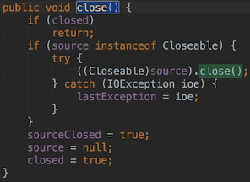

**BufferedReader**  
* **BufferedReader**  
* BufferedReader reads text from the input stream and buffers the characters into a character array.  
* We’re gonna use the FileReader as an input stream for the BufferedReader.  
* **Reading chunks of data from a stream such as a file is more efficient than reading just a few characters at a time and the reason for that is that things like the overhead seeking to the correct track and sector on your disk drive are significant so it takes a while to find the correct place on the disk drive to read from and if you have to do that many times because only a few bytes are being read at a time, then the seek times for this really do add up so consequently BufferedReaders can be a lot faster and more efficient**.  
* You can specify the size of the buffer but the default is 8k bytes so that’s enough for most purposes.  
* Our files here are both smaller than 8k so what that means is the entire contents of the file will be read into the buffer in a single read and be available from there for the scanner to use it.  
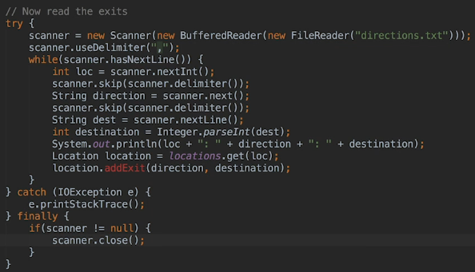  
* This is the close() method of the BufferedReader:  
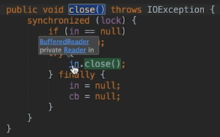  
* The scanner may not be the best way to parse this data, the thing to remember with scanner is that they can be notoriously difficult to use and really can take some trial and error to get them to behave properly with a particular data set.

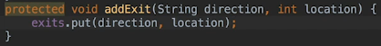  
* We’re gonna add the addExit() method as protected so it’s only available to classes in our package and of course subclasses of Location as well.  
* Another way to parse this data is to read it line by line and then we could use the **String class**   
**split()** method to get each part of the line into a String array, it’s then quite simple to parse the values that really should be integers.  
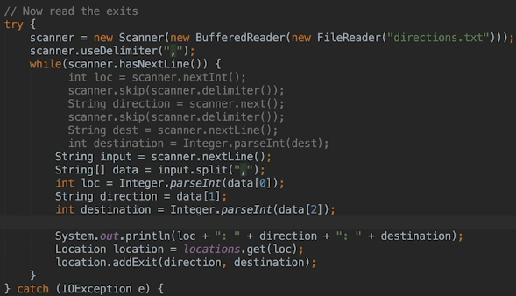  
* With the small number of locations that we have at the moment, the advantage is not really obvious but in the next video I have a download for you in the Resources section oand we’re going to use those files instead because I gota lot more locations and as a result you’ll sort of see the advantages when you’re dealing with larger text files.

**Load Big Location and Exits Files**  
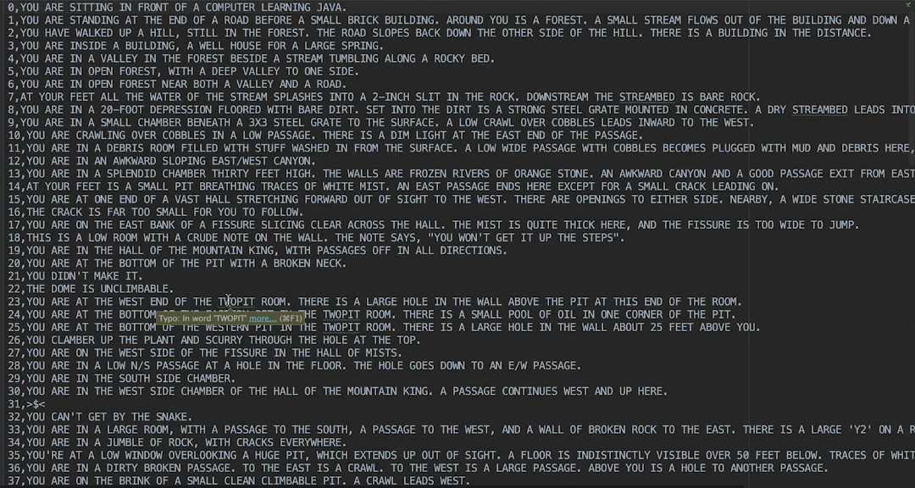  
* We’ve now seen a simple way to write data to a file and to read it back again and in the process we looked at the FINALLY block to ensure that the cleanup code is executed even if an exception is thrown and we’ve also chained objects together and we also covered the TRY with resources method that became available with Java 7 and that resulted in much cleaner code. Now I haven’t used that in the example that reads that data back in, mainly because it’s important to understand how to perform I/O with older Java versions when you have to maintain legacy code and that will happen quite a bit. The second reason was that it makes for a good challenge for you to do it.  
* The code to read the data back is a bit cluttered, catching exceptions and we don’t actually do anything with those exceptions but unfortunately our options are limited here. When we had code in our main method, we could just specify that the method throws the exceptions and remove the CATCH block. That approach can’t be taken with a static initialization block and the reasaon is that the static initialization block is executed when the class is loaded so there’s no way for any of our code anywhere to catch any exceptions that are thrown.  
* You can throw UNCHECKED exceptions in an initialization block but not CHECKED ones.  
* UNCHECKED exceptions don’t have to be caught but CHECKED exceptions must be.

**Challenge**  
* Rewrite the static initialization block using the TRY with resources.  
* Change:  
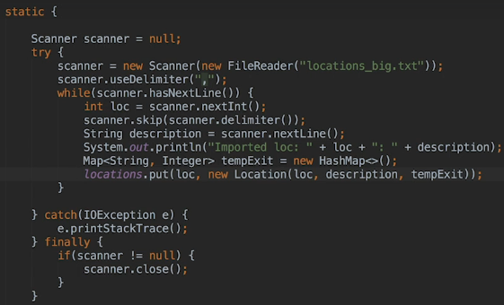  
* To:  
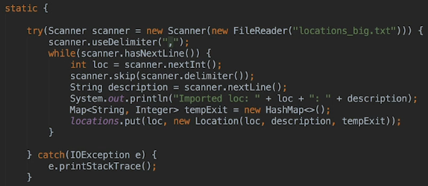

* Change:  
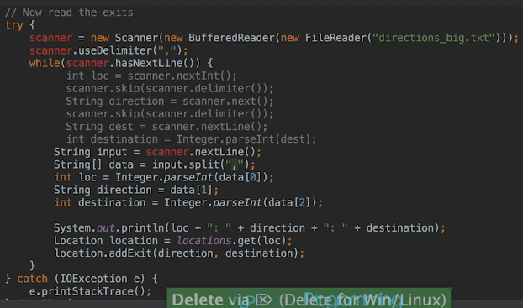  
* To:  
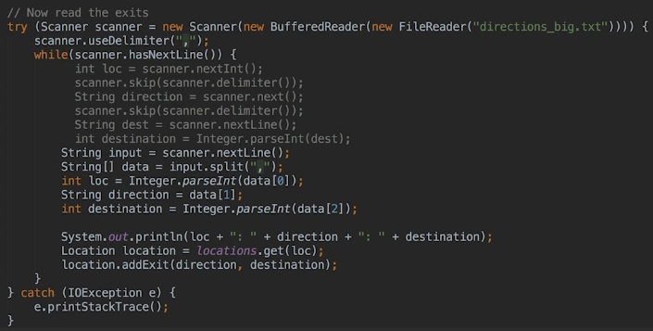  
* You may have noticed that we actually stopped needing a scanner to read the exits when I change the code to read a line at a time and split it. So removing the scanner it’s actually quite easy.  
* **readLine()**  
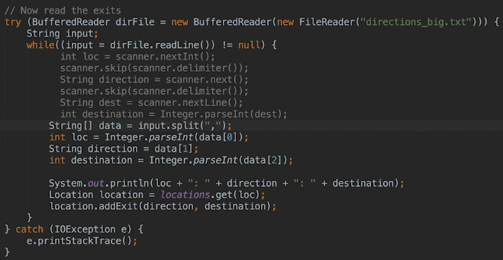  
* If we did this when we stopped using the scanner, than the BufferedReader class close() method throws an UNCHECKED exception so I would’ve had to have caught that in the FINALLY block as well.

**Buffered Writer and Challenge**  
* We discussed the idea of buffering the stream so that large chunks of data are read into memory by BufferedReader, this prevents excessive access to disk because the data is only read from the disk when the buffer is empty, otherwise the FileReader continues to take data from memory buffer so it’s much more optimized compared to just sort of reading a character at a time.  
* We can also buffer data when it’s written to a disk.  
* The concept is the same.  
* **BufferedWriter**  
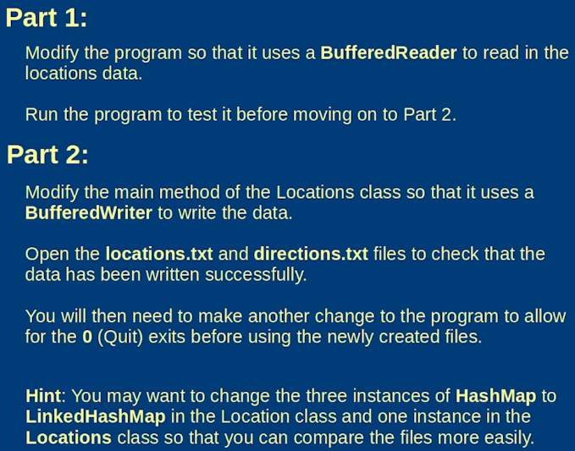  
* In Locations:  
  
* Let’s change the exits to LinkedHashMap for easier testing:  
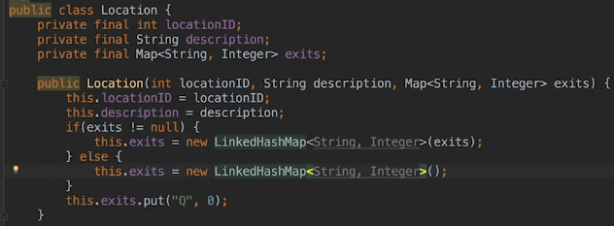  
  
* Let’s also change the locations to LinkedHashMap:  
* Let’s use a BufferedWriter in the main method in Locations:  
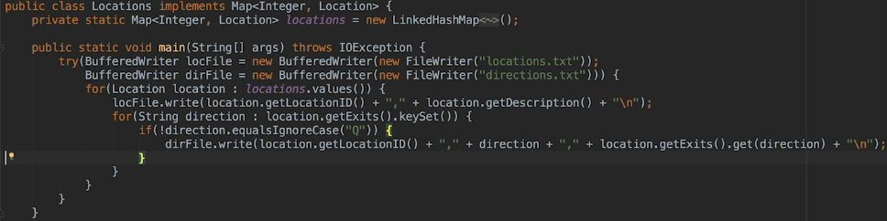

* We also added a line to not include 0,Q,0.

**Byte Streams**  
* This is what we have in Locations.java static initialization block right now:  
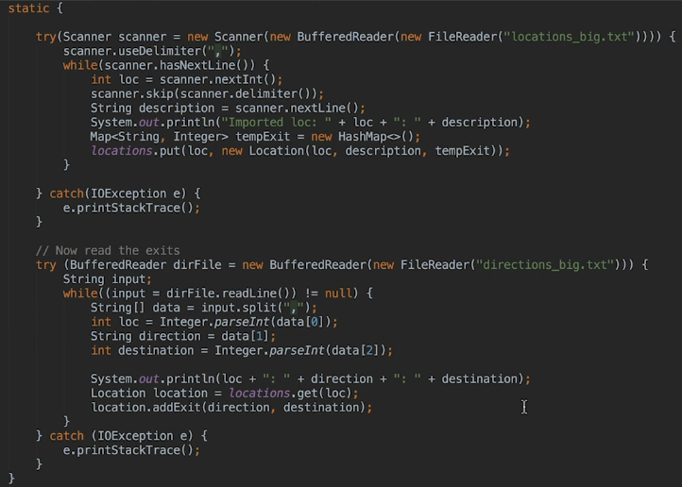  
* In terms of binary data one advantage of dealing with the BYTE STREAM is that we don’t have to parse the data into the various data types that were stored. That’s because the BYTE STREAM itself can be used to read and write any of the Java Primitive Types and it can also handle String variables even though it’s not actually a primitive type.  
* **The difference is that we’re going to use**:  
* **FileInputStream()**  
* **FileOutputStream()**  
* **Instead of the FileReaders and FileWriters**.  
* **We could work directly with these objects but they only handle RAW BYTES so reading or writing etiher a SINGLE BYTE or a SPECIFIED NUMBER OF BYTES**.  
* There are probably occcasions when that’s probably all you need but generally speaking when storing and retrieving data you probably want to work with Java types.  
* The Java IO package makes it easy by providing the DataInputStream and DataOutputStream classes and they provide methods such as readInt() to read an integer value from the stream. It does this by reading 4 BYTES from the stream and building up the integer from those 4 bytes.  
* **DataInputStream()**  
* **DataOutputStream()**  
* **BufferedInputStream()**\* **BufferedOutputStream()**  
* **writeInt()**  
* **writeUTF()**

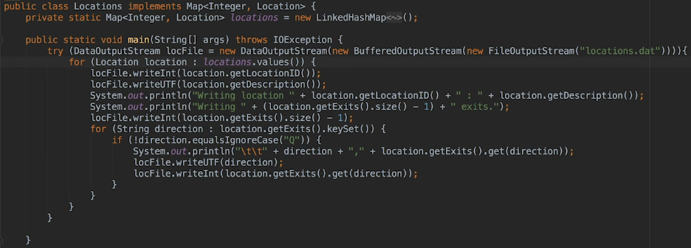  
* We don’t want to record the quit and that’s why we deducted 1 from the total size.  
* It’s a good idea as you’re writing your code to have this sort of debugging capabilities (printing out) built in and adding and updating as you update this particular method if you’re writing new data to the file, update your debugging information as well because it really makes it easier to work on this in the future.  
* Later in the course I’m gonna look at logging because if you think about it, this output shouldn’t really be shown to the users of the program so it’s better to write it in a log file where it’s hidden from users but is available to us as developers if we need to diagnose errors in the future.  
* We’re now writing locations and exits all in the same file. Because locations have different numbers of exits, the number of exits is written first and followed by the exit data for that location.  
* If you think about it, there’s no reason why we couldn’t have done that for the text files as well but it was useful to see how data from different files could be related and that’s the reason that I used that different approach.  
* In the case of BINARY DATA, humans wouldn’t be reading the contents of the file so we put it in 1.  
* You may feel that having separate files makes the code easier to debug in which case it’s fine to do it that way, it’s your code after all.  
* **But either way it’s a good idea to understand the options when making a decision**.  
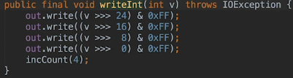  
* **>>>** is called the **shift right 0 fill operator**. It’s actually moving the top 8 bits - the highest byte into the lowest position by shifting them right 24 places.  
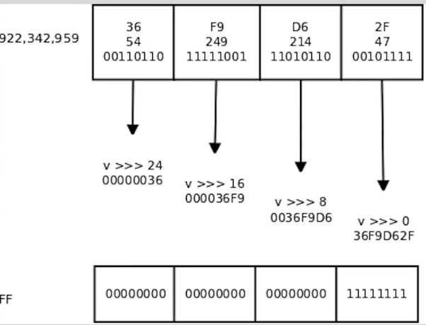

**Reading Binary Data and End of File Exceptions**  
* Let’s create a ShiftInt class to show the 4 values that the writeInt() method produces when it saves an int value to the binary stream.  
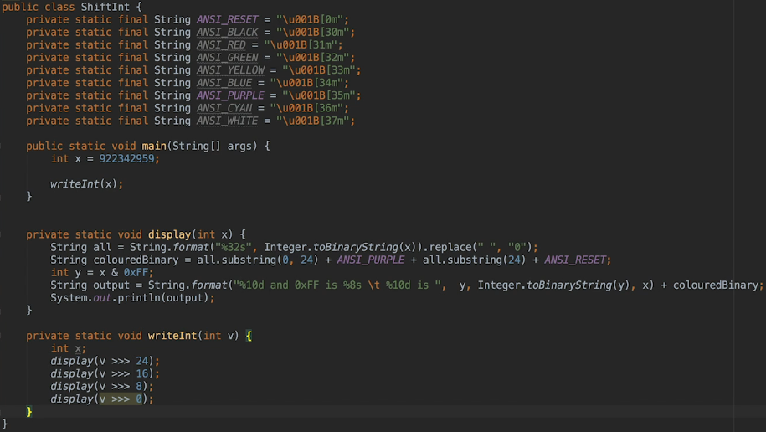  
* **display()** => to do some formatting so the output is easier to read.  
* I’ve also used technique that may not work on some Windows versions, to show the right-most 8 bits in a different color to make it easy to compare the end values with the values they’re produced from.  
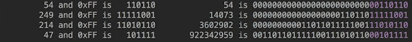  
* The original values are written to the file as the 4 BYTES 54, 219, 214 and 47.  
* The output shows how those values were obtained by shifting the binary number right, then masking of all but the right-most 8 BITS and that’s what the code `int y = x & 0xFF` is actually doing.

* Let’s now read the data from the binary file.  
* It’s actually easier than reading the data from a text file because we don’t have to do any String parsing to get the integer values.  
* So the DataInputStream class takes care of building primitive types such as int and double from the BYTES in the file.  
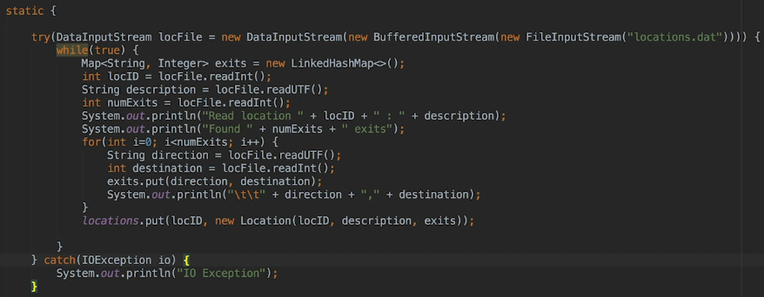  
  
* **The Java documentation should be read carefully before applying it to your own code and it’s quite easy to pick up on the fact that the data stream readers throw an IO exception when there’s no more data to be read from the stream and in fact they throw a subclass of IO exception called EoF Exception and we should really be checking for that to terminate the while loop rather than just using the IO Exception**.  
* The way we have it isn’t the best way of terminating the while loop and that’s because the IO Exceptions are going to cause the program to jump out of the while loop and be caught in the CATCH block but the code really is messy and for example what happens if an IO Exception is raised for another reason than the End of File. So it’s very difficult to treat a real exception such as the input file not being found or having insufficient permission to allow us to open it, differently to the End of File being reach which is an expected event.  
* The point is that it’s very easy to xause an exception but we’ll just try to read the binary data from a file that doesn’t exist by changing the name. That will throw a NullPointerException.  
* Let’s now check for the EoF exception:  
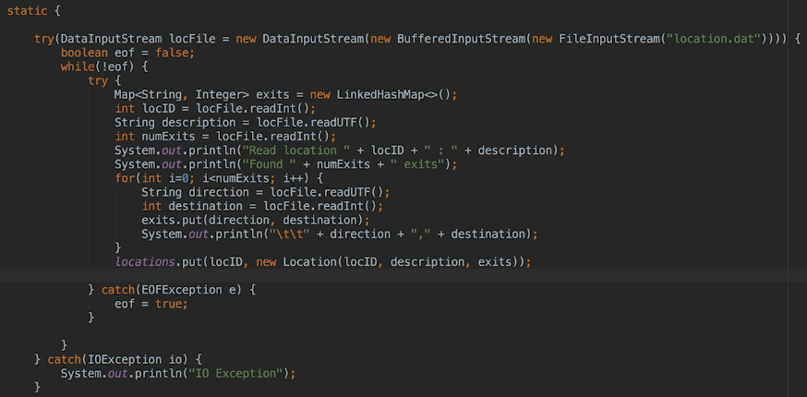  
* **The other good point here is that any other exception is gonna be caught by the TRY with resources CATCH block - the outer one**.

* So working with BYTE STREAMS is really no more complicated than reading and writing CHARACTER STREAMS but you do have to know the format of the data that you’re reading.  
* For example a sequence of 4 BYTES in a BINARY file could be a single int, 2 shorts or 4 bytes for example and you wouldn’t know that if you weren’t involved in the process that created that file.

**Object Input Output including Serialization**  
* **Right now, we read and write each object field invidiually**.  
* We use readInt() and writeInt() methods to read and write out location’s ID.  
* We use readUTF() and writeUTF() methods to read and write a location’s description.  
* If an object had 20 fields, we would have to call 20 methods.  
* **ObjectInputStream**  
* **ObjectOutputStream**  
* We can use these to read and write objects as a single unit.  
* When we write an object to a file, it has to be translated to a format that can be stored to a file and then reassembled into an object later when it’s read by an application.  
* The process of translating a data structure or object into a format that can be stored and recreated is called **Serialization**.  
* In Java, when we want to use an object stream to write and read the objects of a class, we have to make the class **Serializable** (by implementing the Serializable interace).  
* This interface has no methods, it’s just used to give the JVM a heads up that we may want to serialize the object to storage and to read it gback again at some point.  
* When we make a class serializable, it’s strongly recommended that we declare a LONG field called **serialVersionUID**. If we don’t do so, the compiler will give us a warning. This warning can usually be turned off when using an IDE, and unfortunately sometime’s off by default, and it will let them calculate a default value for us.  
* However, different compiler implementations may calculate different default values and that can lead to problems down the road if we change the compiler we’re using.  
* **For that reason it’s recommended that if we care about serialization, we set the serialVersionUID field ourselves. It’s recommended that the field be private since no other class should have to use it**.  
* Think about this number as sort of a version number for the class. If we don’t explicitly set it, the compiler will create it based on class details such as the number of fields and methods. And if we ever change the class, for example by adding another field or method, or change a field type, we’d have to change the serialVersionUID value.  
* When we read an object from a stream, the Runtime checks the stored serialVersionUID against the one contained within the compiled class file. If they don’t match, then there’s a compatibility problem and the Runtime will throw an **InvalidClassException**. Now if we wanted later versions of an application to be able to load files created by earlier versions, we’d have to provide custom versions of the **writeObject()** and **readObject()** methods by overriding them.  
* **The bottom line is that we don’t have to worry about declaring a serialVersionUID field unless**:

**A) We explicitly use Serialization - as we do with ObjectInputStream / ObjectOutputStream  
B) There may be a compatibility issue down the road.**

* **But some developers and the Java documentation recommend always delcaring when A) is true or when the B) also is true**.

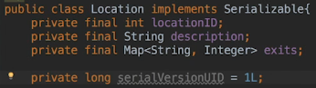  
* int and String are primitive types but Map is an object.  
* LinkedHashMap implements the Serializable interface so that works for us.  
* Ideally, when we want an object to be serializable, all its fields will also be serializable.  
* Now in Locations.java main method:  
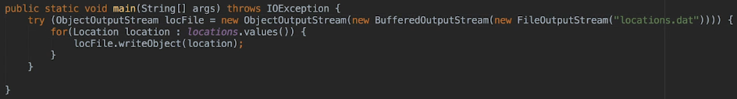  
* Since Location is serializable and all the non-primitive fields in Location are serializable, all we have to do is call **writeObject()**.  
* A file containing serialized objects is meant to be read by a Java application and not by an IDE.  
* The **ObjectOutputStream implements** the **DataOutput** **interface**.  
* The **ObjectInputStream implements** the **DataInput** **interface**.  
* The DataInput and DataOutput interfaces contain the declarations for the writeInt(), readInt(), as well as writeUTF() and readUTF() methods and other read/write specific type methods.  
* Because of that, object streams can contain a mix of serialized objects and primitive types. So in other words, they’re not limited to only containing serialized objects.  
* In our case we don’t need to mix objects and primitives, but we could do it if we needed to.  
* Now let’s read the files:  
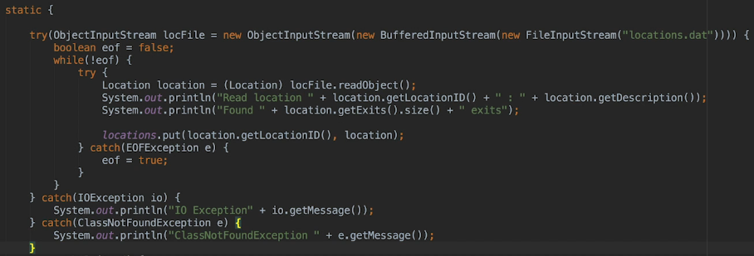  
* **getMessage()**  
* **ClassNotFoundException** => thrown when the Runtime reads an object from the stream and it can’t find the corresponding class on the class path. For example if another application that didn’t contain the Location class, tries to read the objects inside the locations.dat file.

**Finish Object I/O and RandomAccessFile class**  
* The code is now a lot easier to read.  
* If we deleted the serialVersionUID, we get:  


* Before we leave this topic, let’s touch on what happens **when 2 objects that we serialize point to the same object**.  
* As an example let’s say we want to serialize a class called Foo, which contains a field for a Bar object. Now if 2 Foo instances point to the exact same Bar instance, and we serialize the 2 Foo instances to a file, will the file contain two Bar objects or just one? **It’ll only contain one**. Since both Foo instances refer to the same Bar instance, only one Bar instance is serialized. So a serialized file will only ever contain one copy of the same instance.  
* Now imagine we wanna do the same thing but for some reason we wanna create 2 files. So we write both Foo instances to file 1 and then both to file 2. So how many instances of Bar will be written this time? Two. Object instances will be unique within a file, but not across files. So in this case, when the 2 files are read back into an application, 2 distinct instances of Bar would be created. This may not matter, but it could, which is why it’s important to understand that it can happen in this case.  
* Of course, in the 2 file case, there could also be 2 instances of each Foo object read back in as well.  
* To close the section on the java.io package, we’re gonna take a look at the java.io **RandomAccessFile** class.  
* **So far we’ve been reading/writing files sequentially. We didn’t jump around in the file. We’ve only moved forward without skipping any bytes**.  
* Let’s say we have thousands of locations in our file, and every time a player moved to a new Location, we’d read that Location from the file.  
* This is where the RandomAccessFile comes in.  
* Now honestly, it would be far more efficient in that scenario to use an embedded database like SQLite, especially when we’ve got 2 data sets that are related to each other.  
* When accessing a file in a random fashion, it’s important to understand the concept of a **file pointer**.  
* The file pointer is an offset in the file where the next read or write will start from. For example if the file pointer is set to 100, then the next time we call a read or write method, the read or write will start at byte position 100 in the file. If we’re reading an int, the byte set positions 100 to 103 would be read, since an int is 4 bytes.  
* **The byte position is 0-based**. So the 1st byte in the file is at position 0.  
* Whenever we read or write the file, the file pointer is advanced by the number of bytes we read or wrote.  
* We use the term offset when randomly accessing files. An offset is a byte location in the file. So for example if the value has an offset of 100, that would mean that the value is located at byte 100 in the file, so we’d want the file pointer to be set to 100 when we read/write the value. The value could of course occupy more than one byte, but the offset is where the value’s first byte is located, the remaining bytes would follow that first byte sequentually.  
* When using RandomAccessFiles, we refer to each set of related data as a **record**. In our application the locationID, description, exits make up the record for a Location.  
* When the user moves to a location, how will we know which bytes to read from the file? Well, if all the locations occupy the same lengths, and we wrote them out in order, location 1 followed by location 2 etc., that would be easy => we could figure out a location’s offset from its locationID and the fixed location length.   
* Unfortunately, our records don’t have the same length. So because of that, we have to include an index in our file. That index stores the offset and the record length for each location. We also have to include the locationID in the index.  
* **Now given that, reading locations is gonna be a 2-step process**.

**1) We’re gonna get the index record for the location  
2) We’re gonna use the index values and read the location data**  
* So, every index record has to be the same length. Typically, an index contains a unique identifier for each data record, the offset of the record in the file, and the length of the record. In Java that’s 12 bytes.  
* The index for our application is gonna contain the locationID, the location’s offset, and its record length, which matches the typical case.  
* Now because of the description, the location record will always be longer than 12 bytes, so the index will be much smaller than the location’s data. We can access the index record we need by reading it from the file when the user moves to a new location, or we could load the entire index into memory when the application starts.  
* Ideally, we’d want to load the index into memory. And the obvious reason for that is that accessing memory is much faster than accessing files on disc, so loading the index into memory will always provide better performance.  
* Usually, the size of each index record will be smaller than the size of the data records. But when that isn’t the case, then of course it wouldn’t make sense to load the index into memoery if we’re using a random access file, because memory’s tight.  
* Another important point - I’ve been saying that the first data record starts at byte 0, but that won’t be the case if you write the index before the data. We have to save the offset of the data section, which in our case is the locations, to the file. And that’s typically saved near the top of the file.  
* Sometimes the number of data records could also be saved there.  
* For our application, we’re actually gonna load the index into memory. So our file format will look like the following:  
  
* So when we want to move to a specific offset, we’ll use the random access file **sink()** method to move the file pointer. We won’t always have to do this, when we do, we want to do a bunch of sequential read/writes, we’ll start by positioning the file pointer to the offset of where the first read/write will take place. Now if the next read/write will immediatelly follow the previous one, we can just use the readInt(), the readLong(), the readUTF() etc. and the corresponding fuctions writeInt(), writeLong(), writeURF() etc.  
* The file pointer is always advanced by the number of bytes read or written, so if the next piece of data we want to read/write immediatelly followed the last piece that we read/wrote, then the file pointer will be already positioned correctly. In that case we wouldn’t need to call seek() first. So we really only have to call the seek() method when we wanna jump to a different offset in the file.

**Create Random Access File**  
* I’m gonna use the Locations main method to use Random Access File to write out the locations.  
* The locations.data file will have to remain open while the application runs.  
* **rwd** => indicated that we wanna open the file for reading and writing and also that we want writes to occur synchronously.  
* Now you can open a file that’s read-only, we can also not specify that updates to the file have to occur synchronously, but if we do that, and modable threads can’t access the file, you’d actually be responsible for synchronizing the code yourself. In this case it doesn’t matter since only 1 thread will access the file. But generally it’s a good practice to have the Random Access File class handle the synchronization when it does matter.

* So each index record will contain 3 integers - the locationID, the offset for the location, and the size or length of the location record.  
* We’re calculating the indexSize by multiplying the number of locations by the number of ints contained in each record by the number of bytes contained in an integer.  
* On the next line, we then calculate the current position of the file pointer to the index size to account for the value that we’ve already written to the file. And we also have to account for the integer that we’re about to write to the file, the location section offset that we just calculated. So we also have to add the number of bytes to an integer. So this will give us the offset for the location section.  
* As an alternative, we could’ve also added the index size to the size of two bytes, but I like to use the file pointer wherever possible and I suggest that you should probably do that as well.  
* We casted it to an (int) because the file pointer is a LONG value. Now we could’ve written a LONG, but we’re gonna use writeInt() readInt() wherever possible and I suggest that you do that. And if you were working with an application with lots of data, such that the file offsets could be larger than an int could hold, then of course you’d have to stick to using LONGs to make sure you didn’t exceed the maximum size of an int.  
* Alright so we’ve written out that locationStart now, the next section in the file is the index. But before we can write the index, we have to write the locations and that’s because each index record requires the offset for the location. And of course we don’t know the offset until we’ve written the location. Now I guess we could write a location and then write the index record for it, and the nwrite the next location and so on. But that would involved a lot of jumping back and forth in the file.  
* Disc access is expensive and it’s even more expensive when it’s not sequential. So instead, we’re gonna write all the locations and then we’ll write the index as a whole.  
* To do that, we have to build the index in memory as we write the locations.  
* Because we wanna jump back to the file when we finish writing the locations, we’ll save the current position of the file pointer, so that we can jump back to it when we want to write the index, since we’ll write the index after the 2 integers we’ve already written, we’d be writing it to offset 8 which is where the file pointer is currently positioned after writing the number of locations and the location section offset.  
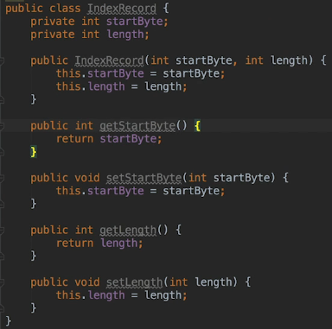  
* We said that an index record could contain the locationID, start offset and length. And when we load the index records into memory, the locationID will act as a Map key and that’s why we don’t have to store it in the class.  
* **getFilePointer()**  
* **StringBuilder**  
* **append()**  
* **equalsIgnoreCase()**  
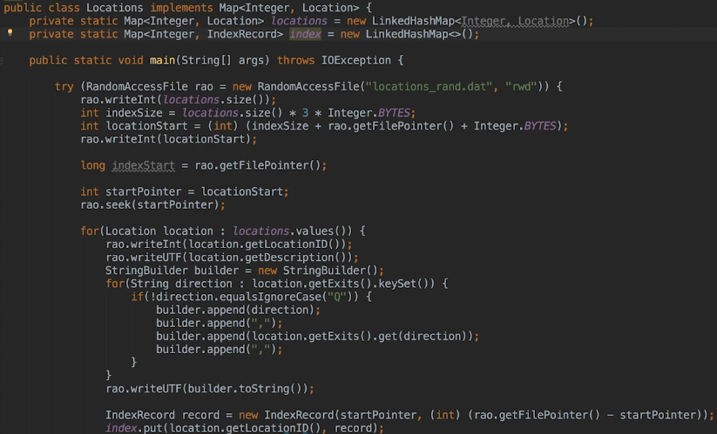  
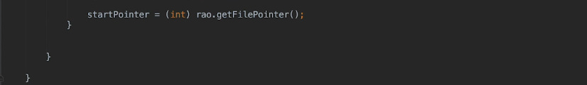

**Update Static Initialized Block With Random File Access**  
* **One drawback to using the RandomAccessFile is that we can’t read/write objects. The RandomAccessFile class doesn’t contain readObject() and writeObject() methods unfortunately. So it’s back to writing each piece of data individually**.

* **Also notice we’re not using a BufferedStream. It wouldn’t make sense when accessing a file randomly because buffering is just like a queue - what goes in first, is read/written first, it’s sequential**.  
* So RandomAccessFile can’t be chained with other types of IO classes.  
* Also unlike the stream and file classes we’ve previously used, it can be used for both reading and writing. So when we actually write a location, we build an exit string that looks like the following:  
  
* The string ends with a trailing comma which we don’t need and if we wanted to be diligent, we’d not write it for the last location. But it doesn’t actually harm anything and disk space isn’t a problem for this file.  
* At this point, we’ve written the location to the file and we can now write our index cause we’ve got the full list of indexes available.

* Now outside the loop:  
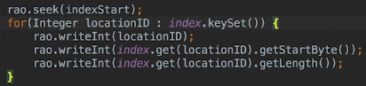  
* Now we want to change the static initializer so that it reads the index from the file.  
* Remember that we won’t be loading the locations into memory anymore. We load locations on demand. Because of that, I’m gonna recommend here that if you need to run the locations.main again, you copy the static initializer that uses that BufferedReader or InputStream from the older project to read the locations from locations_big.txt into the locations Map. Once you’ve done that, you then comment out the RandomAccessFile static initializer. Run the locations main method and them comment out the old static initializer, and finally, un-comment the old one that uses the RandomAccessFile.  
* Let’s now write the static initializer that uses the RandomAccessFile.  
  
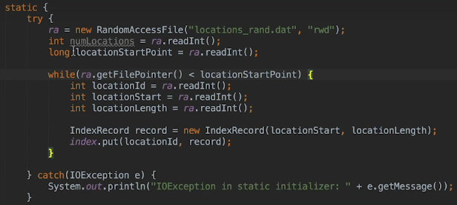  
* We’re not actually using the number of locations, but it’s a good practice to write the number of records in each file section at the beginning of a file that will be accessed in a random fashion.  
* Now the way it’s currently written, it assumes that the locations are all available in memory, but of course that’s no longer true anymore. When a player moves to a location, we have to load that location from the data file.

**Update Adventure Game to Read Random Access File**  
* In Locations:  
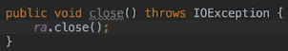

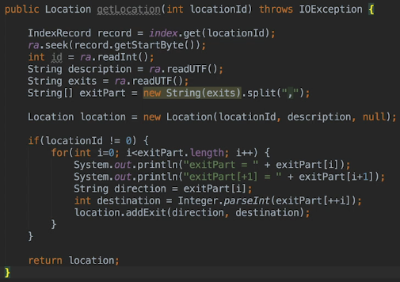  
* ++i => so we’re incrementing i first, and then grabbing that element. Because if you recall, the exits, it’s the actual direction, and then also the locationId where that direction goes to which location it leads to.  
* Even though we know the ID, we’re actually retrieving the locationId because we stored that when we wrote, and I mentioned that’s good practice to do that anyway, in case, for some reason, that you wanted to access it without knowing the locationId. Either way we have to skip past that because we’ve recorded that.  
* **In case you’re wondering how the readUTF() method knows how many bytes to read, because after all, if you think about it, it can’t really know how long the description is, by magic. Well, the reason it knows is because the writeUTF() method actually writes the link to the string, followed by the string itself. So therefore the readUTF() method reads the link first and then it reads the appropriate number of bytes**.  
* We could just use this instead of the new String():  
  
* Now we need to go to the Main class’s main() method to add the call to the getLocation() method.  
* Let’s add throws IOException:

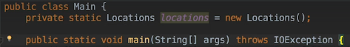  
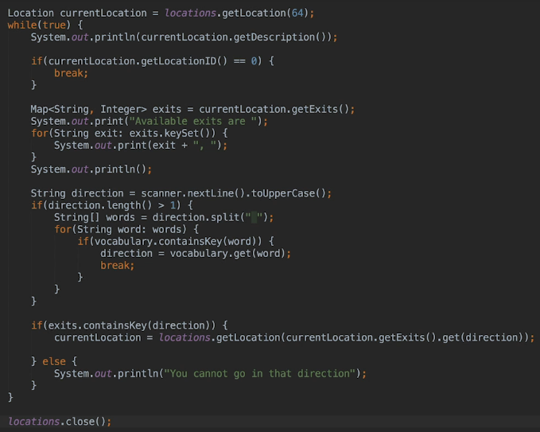  
* So now each location is loaded on demand.  
* We move the file pointer to the offset that we wanna read, and then we read it.  
* If we’re reading/writing data sequentially, we don’t have to explicitly move the file pointer ourselves, but in a Randon File Access scenario, of course, we need to do that.

**Java NIO**  
* In Java 1.4, a new IO package was added to the Java Software Development Kit.  
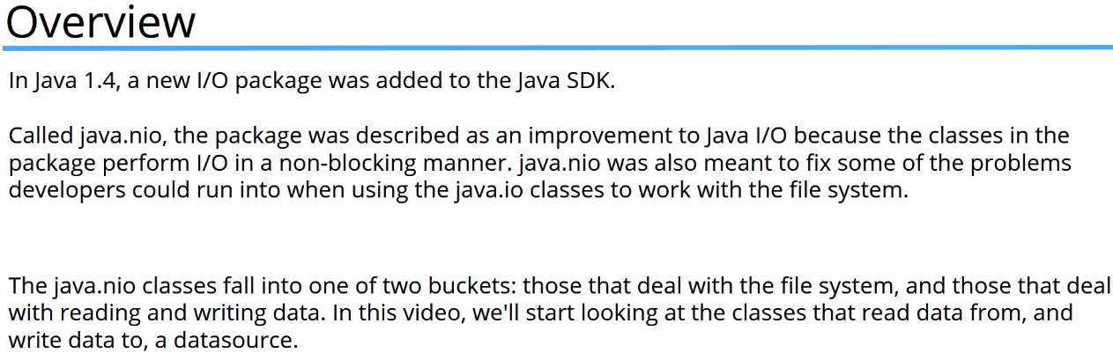  
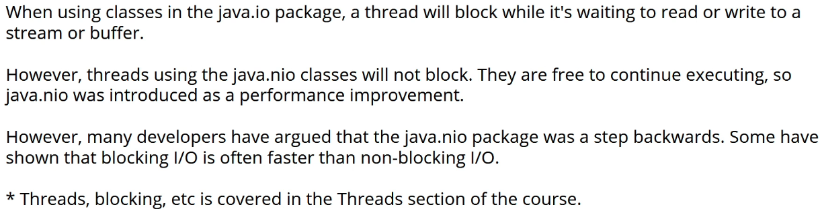



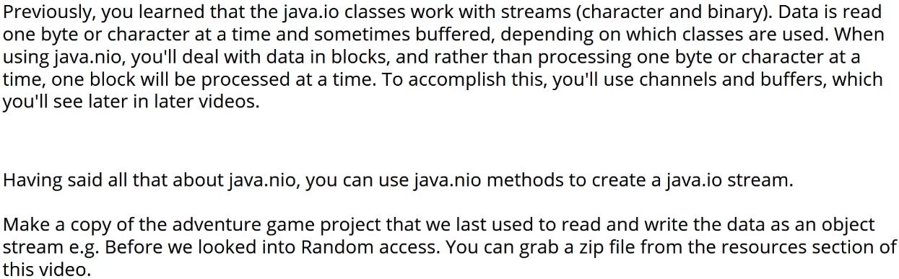  
* Let’s now change the code to read from the big .txt files.  
* We’ll first run the locations main() method to write out the data, and then we’ll change the locations class static initializer which loads the data, when the first instance of the locations class is created. Once that’s done, we can call the main() method from the Main class to run the game.  
* **Path**\* **getPath()**  
* **FileSystems**  
* **getDefault()**  
* **Files**  
* **newBufferedWriter()**  
* **write()**  
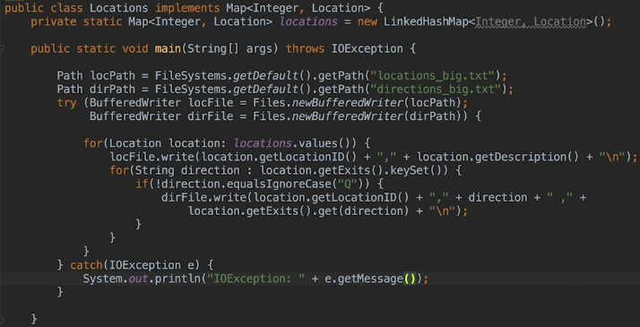  
* Now I’m just gonna paste in the code that we used when we read the file using the java.io that BufferedReader, just so we can see the difference:  
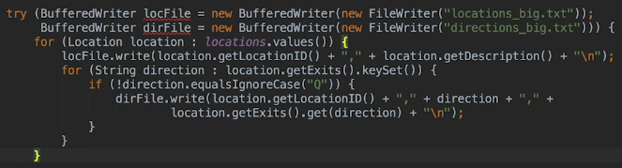

* All that’s really changed is the way we create the BufferedWriter. Instead of creating one directly by calling the BufferedWriter constructor, we’re using the **java.io.Files** class to create the instance.  
* So the Files.newBufferedWriter() method accepts a java.nio.Path instance.  
* We’re gonna look at the Path and the FileSystems classes in more depth later, when you learn how to wrok with the File System. For now, just understand that the Path class is meant as a replacement for the File class, so it’s a more robust class when it comes to working with files.  
* Classes in the java.nio package work with Path instances and not File instances. It’s recommended practice to work with the Path class if using java.nio wherever possible. Sometimes you’ll have to use the File class because a method or a constructor wants a File instance as a paremeter, but when you do have a choice, make sure you use Path over File.  
* Remember that the BufferedWriter wraps another IO class. So when we use the Files.newBufferedWriter(), a BufferedWriter is returned that performs IO using an instance of the java.nio class called **BYTE CHANNEL**.  
* The situation is the same when reading from a STREAM.  
* Let’s now update the static initializer so that it uses the File.newBufferedReader() method to create the BufferedReader.  
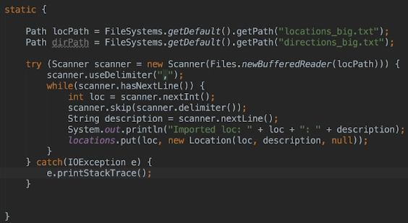  
* Next we’ll add the code, using the Files.newBufferedReader and this time we’re gonna add it for the directions = exits and actually add those as well.

**Writing Objects With Java NIO**  
* This is now all the code in the static initializer for reading:  
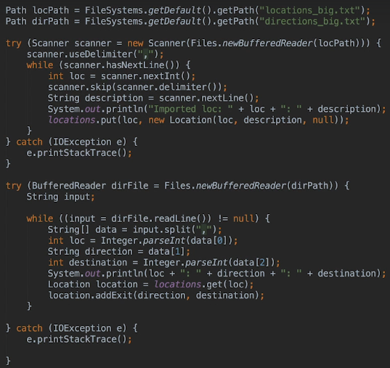  
* Really the only thing we’ve changed here is the Files.newBufferedReader() method call in both TRY statements. Also we had to declare the 2 Path variables. Otherwise the code’s pretty much identical to what it was when you called the BufferedReader() constructor directly in the 2 TRY statements.  
* When you use the Files.newBufferedReader()/Writer() methods to create the BufferedReader/Writer, the underlying instance used to do the IO is a java.nio instance rather than a java.io instance.  
* What about reading/writing objects?  
* There are **newInputStream()** and **newOutputStream()** methods which **return** an **InputStream** and an **OutputStream**. So you can construct a **new ObjectInputStream** / **new ObjectOutputStream**.  
* So you call the Files method to get the appropriate stream and then call the ObjectInputStream/ObjectOutputStream constructor directly using the stream you got from the Files method.  
* For this you no longer need 2 files because you’re gonna serialize the contents of every Location object to the locations.dat file.  
* In Locations main() method:  
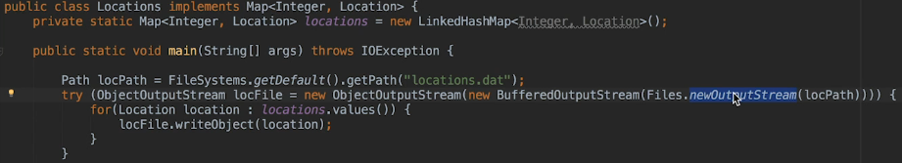  
* **Really the only change we’ve made compared to the IO Object writing is that we call the Files.newOutputStream() rather than the FileOutputStream() constructor**.

* Let’s now modify the static initializer so that it uses the Files.newInputStream().  
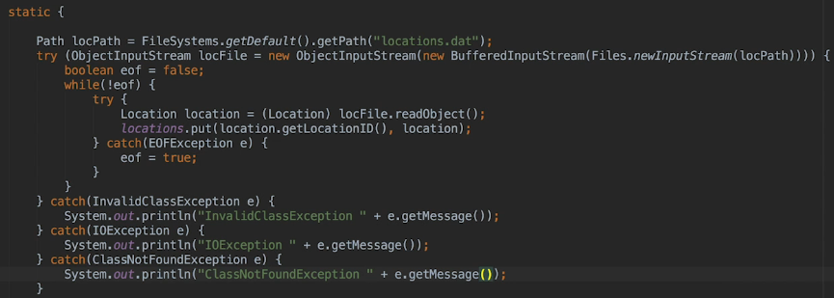  
* **So the code is very similar to the IO way, almost identical, except we’re using the Files.newInputStream() to create an InputStream and then we’re wrapping that with a BufferedInputStream() and then we’re finally wrapping that with an ObjectInputStream()**.  
* **So essentially you can use Files.newInputStream() / Files.newOutputStream to create any stream that descends from InputStream / OutputStream**.  
* **So now you know how to use Java NIO classes to create commonly used Java IO streams**.  
* **Doing IO using Java NIO means the data is processed in BLOCKS rather than ONE BYTE / CHARACTER at a time. To accomplish this, Java NIO uses CHANNELS and BUFFERS and sometimes SELECTORS**.  
* In the next video, we’re gonna start looking at how to read/write text files using Java NIO exclusively.

**Reading and Writing with Java NIO**  
* **Channel** => the data source you’re reading from or writing to. For example can be a **file** or a **socket**.  
* To use a data source as a channel, you need a class that implements the **java.nio.channels.Channel** **interface** and that can connect to the data source.  
* **Buffer** => the container for the BLOCK of data that you want to read or write. Buffers are types and that means that they can only hold one type of data. You can specify the size of the buffer as well.  
* **Selector** => they allow a single THREAD to manage the I/O for multiple channels.  
* **We won’t be covering selectors because they’re really only generally needed in large enterprise applications**.  
* When working with streams, which can be BYTE-based or CHARACTER-based, you need 2 instances of the Java IO class if you want to both read and write a file.  
* **When using Java NIO, you only need 1 instance of a Channel to both read and write to same data source**.  
* **Also reading and writing is always buffered**.  
* The JDK contains channels for several data sources, including files, network I/O, as well as sockets.  
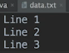  
* Let’s create the channel that’s going to be used to read and write the file.  
* **There are 2 ways to do this**.  
**1) You can create a channel from an opened file instance  
2) You can use the FileChannel.open() method**

* Let’s start by creating a channel from an opened file.  
* **We can get a FileChannel from the instances 3 classes: FileInputStream / FileOutputStream / RandomAccessFile**.  
* **FileChannel**  
* **getChannel()**  
* **FileChannel is an exception to the rule that you only need 1 channel**:  
1) If you create a FileChannel from a FileInputStream, it’s actually only open for reading.   
2) If you create a file from a FileOutputStream, it’s only open for writing.   
3) For RandomAccessFile, it would depend on the parameter you passed to the RandomAccessFile() constructor -- R RW.  
* Under the covers, FileChannel is an instance of SeekableByteChannel and we’re working with text so you might think it should be easy to read a string or text from a file using Java NIO but it’s not or at least it wasn’t until fairly recently.  
* When you create a buffer to use with a channel, you have to specify the size of the buffer which will specify how many bytes are read from the file at any one time. What about a file that would contain lines of different lengths? If 1 line had 25 bytes and the 2nd line had 100 bytes, you’d either read 100 for the 1st line or you’d have to read multiple times for the 2nd one.  
* Fortunately, new methods were introduced to the java.nio.Files class in Java 8 that makes it easy to read one line of a text file at a time.  
* **readAllLines()**  
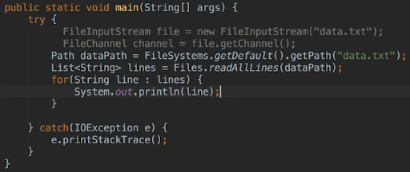  
**\* If you want to access a file in a random fashion, then you get a FileChannel from an instance of RandomAccessFile**.  
* Now let’s write to a file.  
* There are a few things to note here:  
1) When using the Files class to write a text file, each write is considered an isolated write in a sense that each call to **Files.write()** involves opening the file, writing to it and then closing the file. Because of that, if you wanted to write more than one line, you’d typically use something like StringBuilder to build the text up and then do it all in one shot.  
2) The Files.write() method writes bytes, not strings. So we’re gonna be calling the   
**String.getBytes()** method to convert a string to a byte.  
* The only thing there that could potentially be confusing is the fact that we’ve got a string here that we wanna write but we’re using the getBytes() method and passing the parameter if **UTF-8** for the character set.  
* When using the Files.readAllLines(), the UTF-8 is assumed, but you can specify whichever character set you want as a second parameter.  
  
* **StandardCharsets.UTF8**, **StandardCharsets.US_ASCII**  
* **StandardOpenOption.APPEND means that you append bytes to a file that already exists**. If you don’t specify this 3rd parameter, the method assumes that you want to start fresh.  
* Also the Files.readAllLines() reads the entire file into memory. What would you do if you needed to read a huge text file and you didn’t want to read the entire thing into memory? Honestly, then you’d use the Java IO classes. You could use a ByteBuffer and go through the pain of pausing at each line, you could also call Files.newBufferedReader to create a BufferedReader that’s using a ByteChannel under the covers. But as I mentioned earlier, some developers have benchmarked java.io VS java.nio and found that java.nio is actually often much slower.  
* If you’re working with a huge text file, another thing to consider is using a different file format. Perhaps you should be using a database rather than a flat file. The adventure game examples that we’ve worked with use small files but since there’s a relationship between the locations and the exits, it may have made more sense to store the data in a database and retrieve it on demand as you did when using the RandomAccessFile class.  
* The only case in which java.nio might be the recommended approach is when you’re working on a large application that uses multiple threads to do IO. Otherwise, my opinion is that java.io is absolutely fine to use.  
* As you’ll see later, though, java.nio is an improvement when it comes to dealing with the File System.

**Writing Binary Files with Java NIO**  
* Because we’re writing to a file, we’ve got the data, so you can create a ByteBuffer that matches the length of the data.  
* **Buffer’s Capacity** => the number of elements it can contain.  
* **Buffer’s Position** => the index of the next element that should be read or written. It can’t be greater than the Buffer’s Capacity.  
* **Buffer’s Mark** => used by the **Buffer.reset()** method, when this method is called, the buffer’s position is reset to its mark. If you know you wanna rewind the buffer to a certain point, you’ll mark the point, and then later you can call the reset() method to reset the position to the mark.  
* **ByteBuffer.wrap()** =>  **1) It wraps the Byte Array into the Buffer, that means that the Buffer is backed by the Byte Array. This is important. Modifications to the Buffer will change the array, and modifications to the array will change the buffer**.  
* If you use the buffer to write out our bytes and then you use it to read from a file, the output byte array will be changed, it’ll no longer contain what it did initially.  
* So essentially, when you call the ByteBuffer.wrap() method, you’re telling the Runtime that you wanna use the byte array as the buffer. And since you’ve used wrap, the buffer is already filled.  
**2) It sets the position of the buffer to 0 and when you use the buffer, the read/write will start at position 0**.  
**3) The buffer’s capacity will be set to the byte array’s length**.  
**4) The buffer’s mark will be undefined**.  
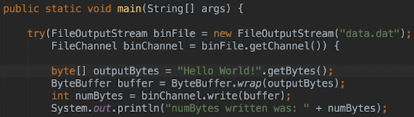  
* **If you wanna know how many bytes are actually written, you can get that from the write() method’s return value**.  
* **You have to close the InputStream and the FileChannel, for that you can use TRY-with-resources**.  
* **ByteBuffer.allocate()**  
* **Integer.BYTES**  
* **putInt()**  
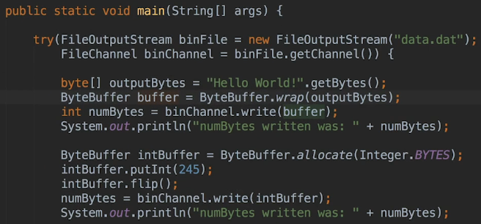  
* **You have to explicitly reset the buffer’s position to 0 if you want to start reading from the beginning**.  
* **ByteBuffer.flip()** => **resets the position to 0 and discards any mark that have been set**.  
* **The ByteBuffer.wrap() resets the position to 0 as well**.  
* If you had 20 ints to write, you could create a buffer large enough to accept 20 ints and then call the putInt() method 20 times. Each write would start at the buffer’s position in that case. For the first putInt() the buffer’s position would be 0, the 2nd call would be 4, the 3rd would be 8, given that 4 is the number of bytes for an integer.  
* **Note that you can write to an explicit index in the buffer. To do so, you pass a 2nd parameter to the put method, that specifies the start index for the read or write**.  
* We need to flip before putInt(-98765) as well because after we wrote the 245, the buffer’s position was set to 4. But the buffer is only 4 bytes long and the position is 0-based. So 4 is actually out of bounds of the buffer’s capacity, there’s no room at position 4 to write any more bytes.  
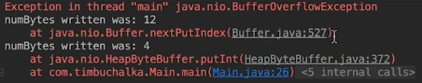  
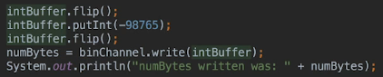  
* If you’re going to do multiple writes to a buffer before writing the buffer to a channel, you don’t have to call flip() after each write. But you do have to call it whenever you flip from reading to writing or writing to reading --- hence the name flip.  
* When you’ve filled a buffer, and you’re ready to write it to the channel, you’ll actually be reading from the buffer at that point, and then read from the buffer and write to the channel, and hence the call to flip is required.

**Reading Files with NIO**  
* We’re gonna use java NIO but we’ll start off using java IO to accomplish this reading of the data back into the application.  
* **If you recall when you use methods such as writeUTF(), the length of the string is written before the string itself so that when the readUTF() method is called, the method knows how many bytes to read**.  
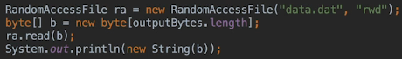  
  
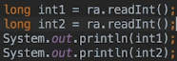  
  
* **This confirms that it doesn’t matter that we wrote it using NIO and read it using IO**.  
* **Now let’s read the file using java.NIO**.  
* We’re gonna use the existing buffers to read the data back into the application.  
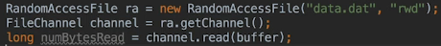  
* Now to print the string, we need to access the byte array backing the buffer.  
* There are 2 ways to get at it:  
1) When we called the wrap() method, the byte array we passed as a parameter, is usesd to back the buffer. So after the read, the string should be in the outputBytes byte array. We also need to call the flip() method because we’re switching from writing to reading.  
  
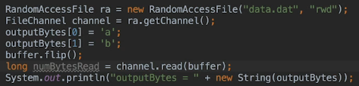  
2) We can call the **ByteBufer.array()** method which returns the byte array, backing the buffer. To do that, it’s good practice to call the **ByteBuffer.hasArray()** method before doing that to ensure that you can access the ByteBuffer backing the array.  
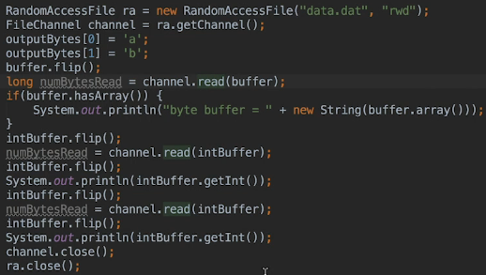  
* We need to close the channel and the file because we didn’t use the TRY-with-resources.  
* **To avoid calling flip(), you can use another version of the getInt() method. When you don’t pass any parameters as we’re doing here, then the read begins at the buffer’s current position. But instead, you can pass an index to getInt() and when you do that, the read will begin at the index you passed**.  
* The first type of read based on the buffer’s position is called a **RELATIVE** **READ**.  
* The second type of read is called an **ABSOLUTE** **READ**.  
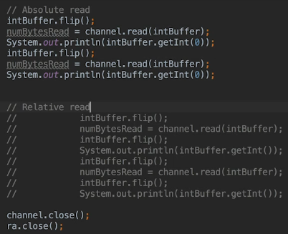  
* So by using the ABSOLUTE READ, we don’t have to flip() the buffer after reading from the file channel, because we used the absolute version of the getInt() method.  
* **You can do relative and absolute gets for all the data types and you can do the same when doing puts() to the buffer**.

**Absolute and Relative Reads**  
* **When you’re using absolute indices, the buffer position isn’t updated**.  
* So the buffer position remained wherever it was before the call.  
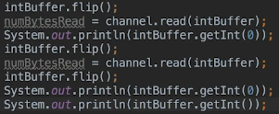  
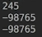  
* If the absolute read had changed the buffer’s position, then we would’ve gotten a java.nio.underflow error because the buffer’s position would have been pointing to the end of the buffer after the absolute read. But an absolute read doesn’t change the buffer’s position and that’s why the relative read we used, succeeds.  
* So I suggest you do it one way or the other, but without mixing it.  
* **At the moment we’ve reused existing buffers. Now of course we could also have allocated new buffers using the ByteBuffer.allocate() method**.  
* Let’s now change:  
  
* To:  
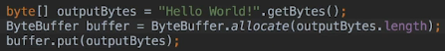  
* **put()**  
* So here instead of using the wrap() method and passing a byte array, we changed this to allocate a buffer and after we’ve allocated the buffer based on the length, we’re using the put() method to copy the contents of the outputBytes byte array into the buffer.  
* **So it’s important to remember that when we used the wrap() method, the byte array passed to the method is used as the byte array that backs the buffer**.  
* **Instead, when we use ByteBuffer.allocate(), a new byte arraya is created and that’s used to back the buffer**.  
* Earlier when we used the buffer created by wrap() to read the string, the outputBytes byte array was updated because it backed the buffer.  
* That won’t be the case anymore because we changed it.  
* If we run the program:  
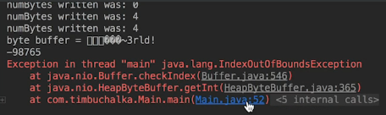  
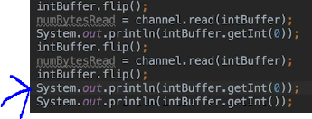  
* **When it comes to NIO, I can give you this mantra: “When something goes wrong, flip()”**.  
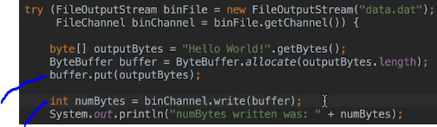  
* When we call the put() method, we write to the buffer. When we call write(), we’re reading from the buffer. But you have to flip() between those 2 actions.  
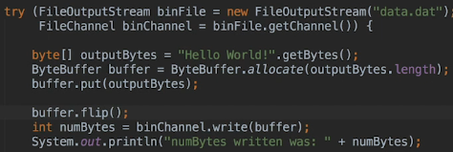  
* It works.

* Now it’s time to read the string back in.  
* The way we’re doing it now is fine because we’re calling the ByteBuffer.array() method to get the byte array backing the buffer.  
* **When you were using the wrap() method to write the string, we didn’t have to call the array() method because the outputBytes array was backing the buffer, but now that we’re not using the wrap() method, that’s no longer the case**.  
* Just to demonstrate that, we’re going to temporarily change the code to print out the outputBytes array instead of the one we get from this array() method call.  
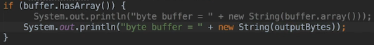  
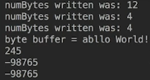  
* The problem here is since the outputString array isn’t backing the buffer anymore, the first 2 characters you set aren’t overwritten when you use the buffer to read the string from the file.  
* So far we’ve been reading and writing variables individually. You write a single variable to the buffer, and then you write the buffer to the channel. And often, you’ll want to write a bunch of data to the buffer before writing the buffer to the channel, or read a bunch of data into the buffer before pulling data from it.  
* So let’s update the code, so that it reads and writes all 3 values in the one shot.  
* Let’s comment everything out.  
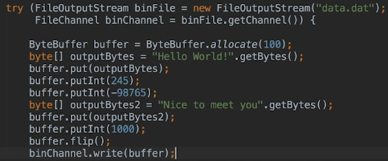  
* We’ve allocated more buffer than we need, but that’s fine.  
* The buffer knows how many lines have been written to it.  
* **We only have to call the flip() method once - after we’ve written all the values to the buffer**. You do so at that point because you’re flipping from writing to the buffer, to reading from the buffer to write its contents to the file channel.  
* We haven’t specified an index for any of the put() calls, and so all the writes are relative writes for that reason, which is what we actually want here when we’re writing the values sequentially.  
* You can see that consequently the code’s a bit cleaner than the previous versions when we were using multiple buffers.  
* In the next video, we’re gonna have a look and see what happens when we remove that flip() call but then continue on and start reading the data back from the file as well.

**Chained Put Methods**  
* If you don’t use the flip() method there before writing, the buffer’s position will be set to after the last value you wrote to it when you call binChannel.write(). Since there’s nothing to write beyond that position, nothing’s actually written to the file.  
* Now let’s read the data in one shot.  
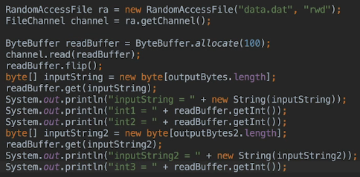  
* **Now we could reuse the buffer that we used to write the data here btw**. But then the buffer’s contents would already be set to the contents of the file. So we’re starting fresh. That way you can be sure that the file was actually read, that’s why we’re doing it this way with the new buffer.  
* The read() method is smart enough to stop reading when it hits the end of the file.  
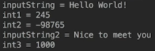  
* **The put() methods all return the ByteBuffer and that’s great because that means we can chain multiple puts together**.  
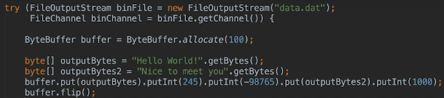  
* We’ve been using a RandomAccessFile to read the file but only because it was convenient to geet a channel from it. Since you’re always reading and writing data sequentially, you could also have used an inputStream. Now other than creating the stream, the code will then be the same.

* **Now let’s learn how to use random access using java.nio**.  
* To jump around in a file, you have to use a SeekableByteChannel which has the notion of a current position. SeekableByteChannel only has a small number of methods:   
1) **read(ByteBuffer)**  
  
2) **write(ByteBuffer)**  
3) **position()**  
4) **position(long)**  
5) **truncate(long)**  
6) **size()**  
* You’ve been using one of the methods all along - because the FileChannel class implements the SeekableByteChannel interface.  
* Let’s modify the code we have to read the integers in backwards order.  
* With RandomAccessFile normally you’d have to have something like an index in the file that would enable you to read values on demand. But we’ve already learned how to do that so we’re gonna keep things simple here.

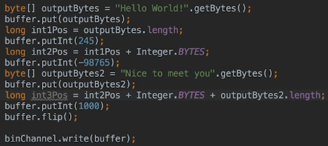  
* It’s the same code as we had before, except we’re now saving the start position of each integer that we wrote to the file.

**Writing Sequentially**  
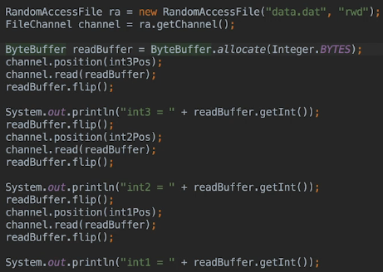  
* When reading in a random manner, probably you would normally create a buffer for each read that matches the size of the data.  
* For example in the adventure game we had, to load a location on demand, then we already know the length of that location record from the index so therefore for each read we’d create a new buffer of that exact length.  
* You might think it’d be more efficient to create a buffer that’s large enough to hold the longest location record and reuse it, but you may never need to load the longest record and Java’s garbage collector will take care of the buffers you’re creating, so they won’t actually clog up memory.

* Now let’s write data in a random fashion.  
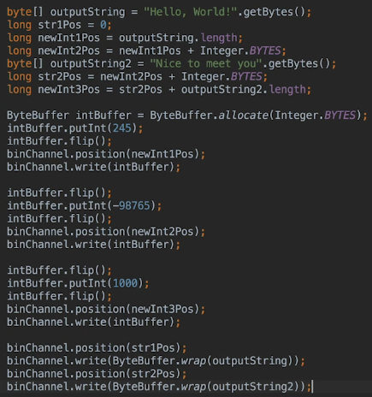  
* **There are other ways to write this code but doing it this way does make each step clear**.  
* Firstly, we’re calculating all the start positions. Then we’re writing the 3 integers and for each integer we’re writing the value to the buffer after flipping the buffer if necessary. Then you flip() the buffer to prepare it for writing to the channel and you then set the channel to the start position for the integer and then you write the value to the file. And for the second and third integers, you have to then flip() the buffer before writing the values to it. The strings are simple becauase we’re using the wrap() method and that takes care of creating and flipping the buffer for us.

* The point here is that you have to understand how important it is to make sure you call the flip() method when changing from reading the buffer to writing it and vice versa.   
* Often the reads and writes aren’t intuitive. For example, when writing a buffer to a channel, the buffer is being read.  
* If you haven’t called flip() when you were supposed to, you’ll usually get a BufferUnderflowException when reading from the buffer.  
* So in the case of writing values, you won’t actually see the value appear in the file. And that’s because you didn’t flip the buffer and the buffer’s position will still be positioned after the value put and so the channel goes to read the buffer so it can write the value to the filea and it thinks there’s nothing to read.  
* In the next video we’ll move to another topic - how you can use a FileChannel to copy one file to another.

**FileChannel to Copy Files and Pipes with with Threads**  
* **FileChannel.transferFrom() => source channel, start position, number of bytes to copy**  
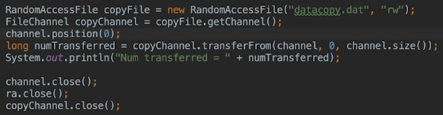  
* We need to use channel.position() to make sure we start copying from the beginning of the file.  
* You need to read the documentation for methods like this to check if it uses the position as an absolute value or a relative value.  
* **FileChannel.transferFrom() => does exactly the same except you call it using the source channel rather than the destination channel.**  
  
* Usually you use a method in the Files class to copy one file to another, but if you’ve already got one of the files open using transferFrom() or transferTo() may actually be a more efficient way to do it depending on the operating system.  
* Let’s take a brief look at pipes.  
* Pipes are used to transfer data between threads and they’re actually a one waya connection so the data can only flow one way.  
* A **pipe** has 2 channels:  
1) **Sink** **channel**  
2) **Source** **channel**  
* One or more threads write/s to the sink channel and the other thread/s read from the source channel.  
* **You need 2 threads - one that’ll write to the sink channel, and the other that’ll read from the source channel**.  
* **Runnable**\* **Pipe.SinkChannel**  
* **sink()**  
* **System.currentTimeMillis**  
* **hasRemaining()**  
* **Thread.sleep()  
\***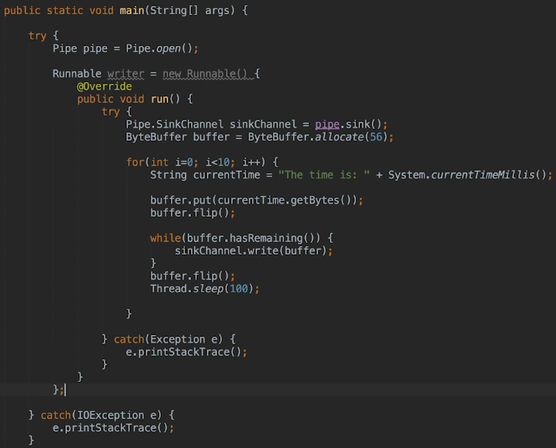  
* **Pipe.SourceChannel**  
* **source()**  
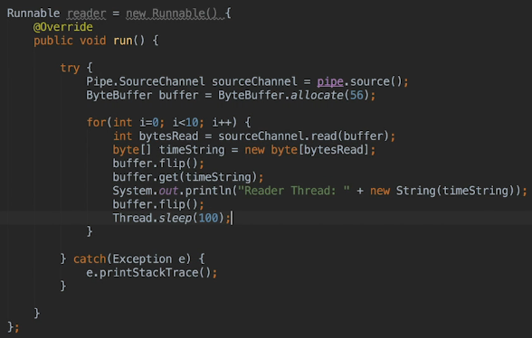  
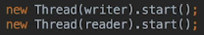  
* There are other ways for threads to communicate and parse data, so it would be a good idea to benchmark the different ways and then choose the one that’s the most efficient for an application.   
* So sometimes using a java.nio pipe may not actually make sense.

**Filesystem**  
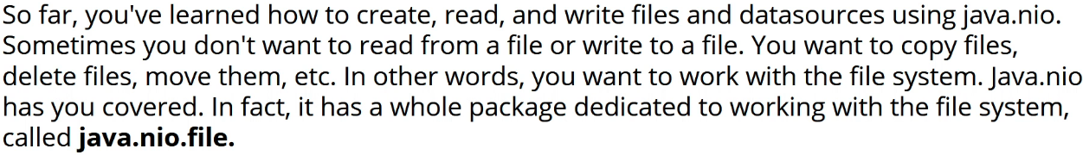

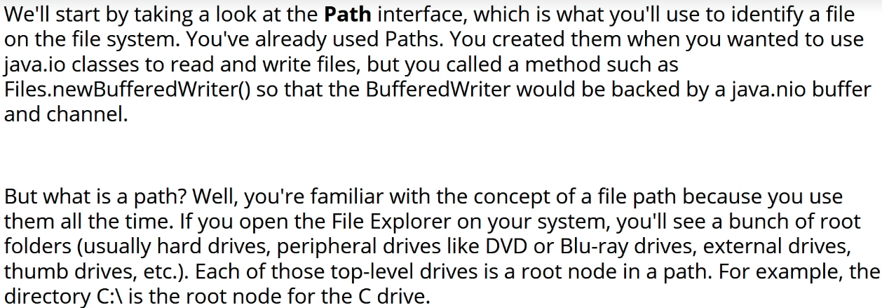

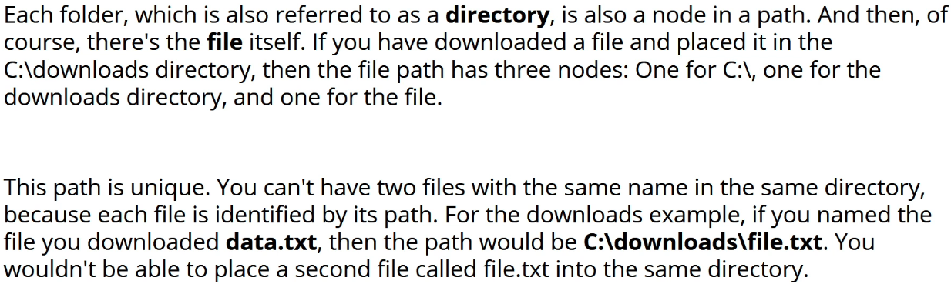

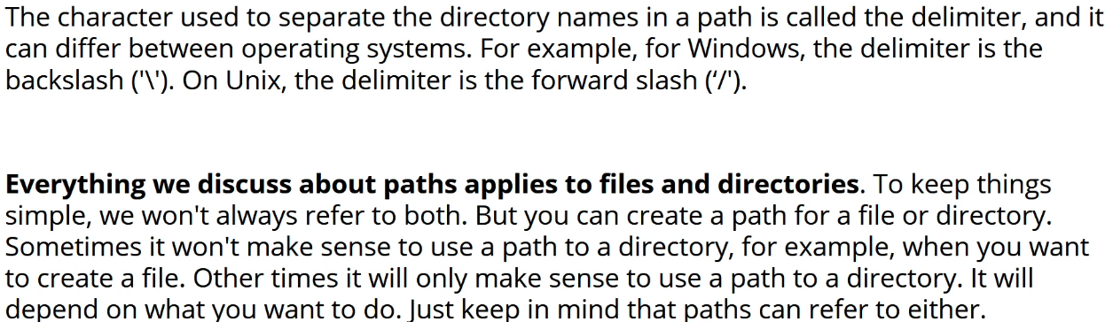

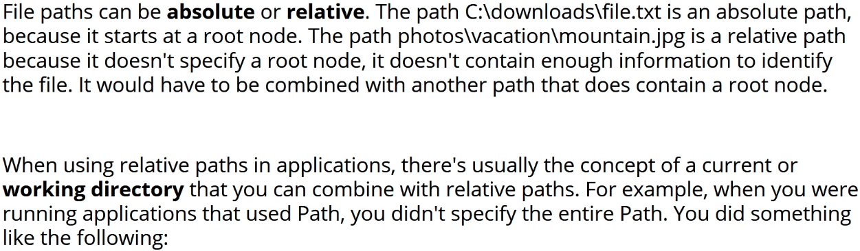

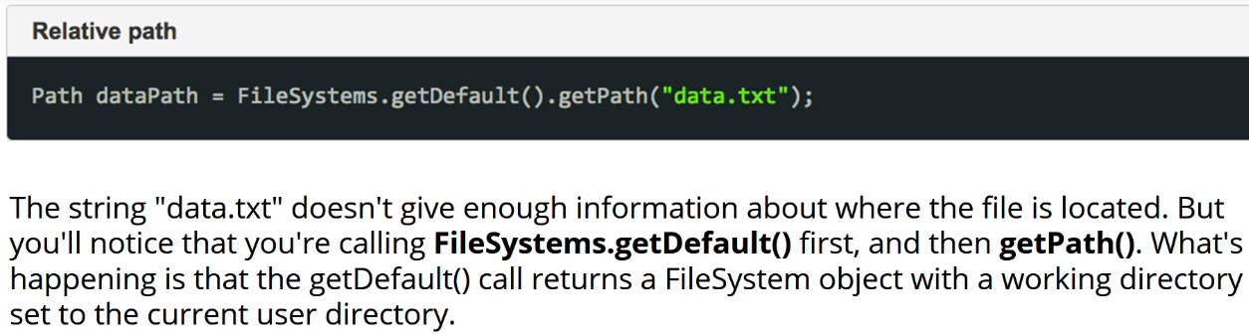

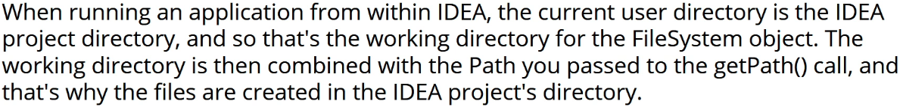

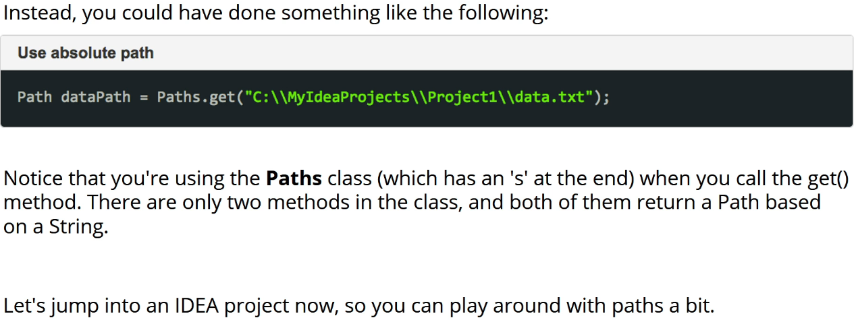  
* Let’s create these folders=directories and files:  
* And also one outside of our working directory:  
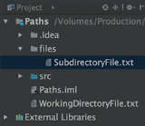   
* **FileSystems.getDefault().getPath()**  
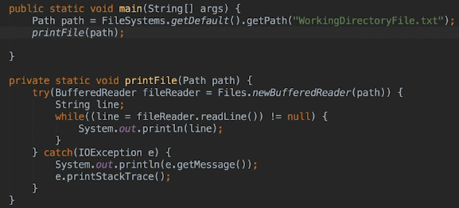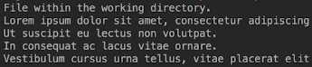  
* **getPath(subDirectory, fileName)**  
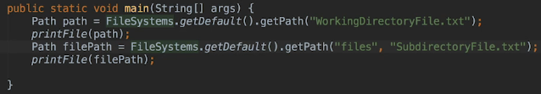  
* **Paths.get()**  
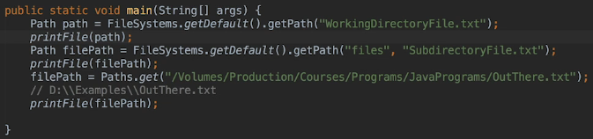

**More on Paths**  
* You can use the long Paths.get() method always but when you know the file’s path will be relative to your working directory, it’s actually more convenient and better practice to get the working directory using the FileSystems.getDefault() and then tacking on the getPath().  
* You have no way of knowing which directory a user will install your application into, so when you want to install files and store them with your application, you can’t specify absolute paths in your code. So you have to rely on getting the working directory for the application.  
* You could have stored install path somewhere but it’s still better to get the working directory using methods because it’s a foolproof way to do it.  
* If a user created files, absolute paths may make sense because usually when the user wants to open them, they’ll navigate to them in the file system.  
* In addition to FileSystems.getDefault() there’s another way to get the working directory for an application.  
=> You can use  **.**  to represent the current working directory.  
=> You can use  **..**  move up to the previous directory.  
* **toAbsolutePath()**  
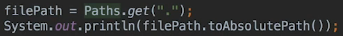

  
* Of course you can build paths relative to any directory. It doesn’t have to be the current directory. But keep in mind that a root node has to be included.  
* You can also split it up like this:  


* Here the . is redundant and .. navigates back to the working directory and down again to the files.  
* **normalize()** => removes redundant path parts.  
  
  
* **It’s a generally a good idea to normalize() the path before using it**.  
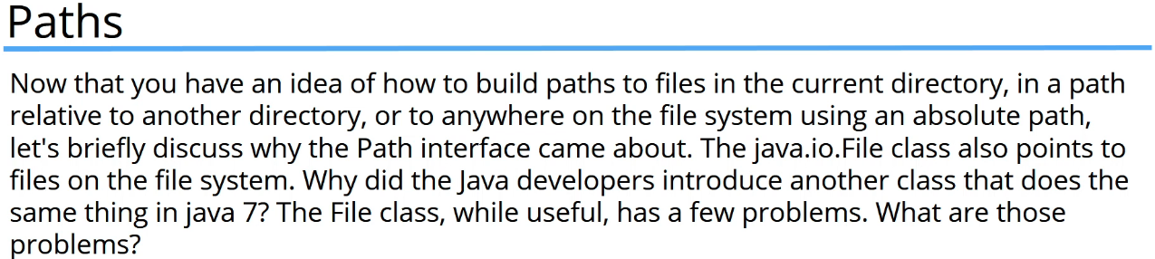  
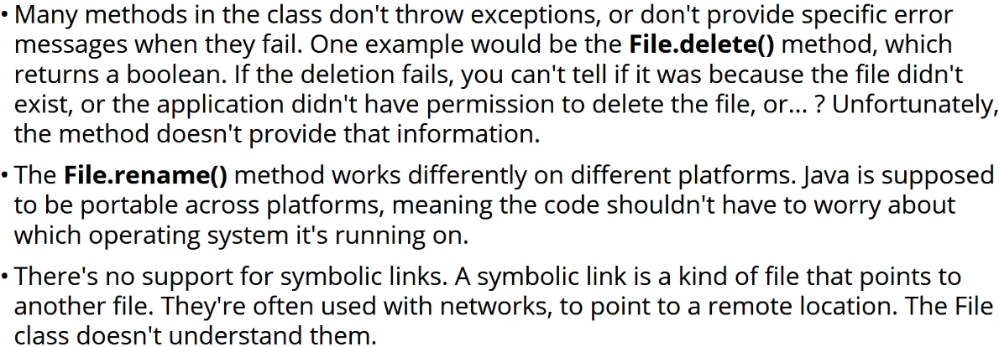

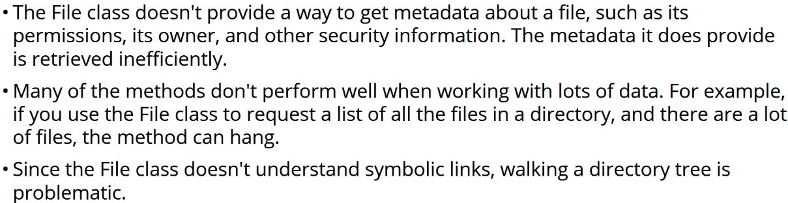  
* **Those are the reason that Path interface was introduced**.  
* Next, let’s have a talk about how java.NIO solves these problems, and also how it splits the functionality that was in the File class, into several different classes and interfaces.

**Exists and CopyFile**  
* java.NIO.**File** class contains methods for pointing to files and also for performing file operations like delete.  
* In java.NIO, the Path interface sticks to File paths. So file operations have been moved to the java.NIO.File.**Files** class.  
* **Files** => contains methods that perform file system operations such as copy, move, delete, etc. All its methods are static so you don’t need an instance of the class.  
* Path interface doesn’t know anything about the file system:  
  
* It created the path which doesn’t exist.  
* The java.NIO.File class operates the same way - until you actually try to access a file, the file nad the path are actually abstract.  
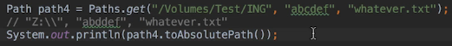  
  
* No exceptions are thrown.  
* Because of this, depending on what you wanna do, it can be a good idea to check for the existence of a file or directory before you try to use it.  
* **Files.exists()**  
  
* **This exists() method has an overloaded method that accepts a second parameter that specifies how you wanna handle symbolic links. So you can choose to follow them or not to follow them. By default they’re followed**.  
* **Files.notExist()** => returns true when the file/directory pointed to by the path doesn’t exist.  
* In a real world application, you could check for the path’s permission in the printFile method and throw an exception if the file doesn’t exist or perhaps just let the IOException be thrown when you try to create the BufferedReader.  
* Now even if a file exists, your application may not have permission to use it, you can check that by using the:  
**Files.isReadable()**  
**Files.isWritable()**  
**Files.isExecutable()**

* Let’s now see how to copy a file.  
* Let’s create the following folder structure:  
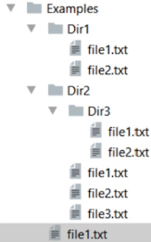  
* **Files.copy()**  
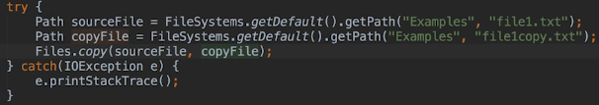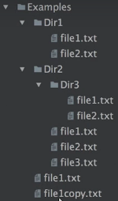

**Move, Rename and Delete**  
* **The copy() method by default throws an Exception if the destination file (copy) already exists**.  
* **To change that and copy() it even if the file already exists, you can pass a 3rd parameter**.  
* **StandardCopyOption.REPLACE_EXISTING**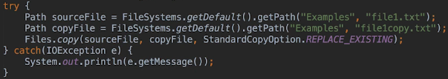  
* You can also copy() directories:  
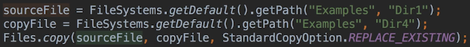  
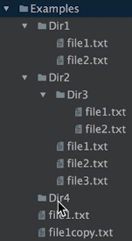  
* It didn’t copy the files that were inside of Dir1 though, that’s how it work by default.  
* **When you wanna copy a directory and all the files and directories it contains, you have to walk the file tree - we’ll see how to do that later in this section**.  
* **Files.move()**  
  
* You have to specify the full path of the destination, just the directory you move it to isn’t enough.  
* **To rename**:  
  
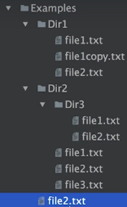  
* **When renaming a file, the source and the destination directories have to be the same**.  
* You can pass a 3rd parameter if you want to move a file to a file that already exists. An example of when you might want to do this is when your application uses temporary files, until the user explicitly asks to save. You then wanna move the temp file to the permanent file and that file may already exist if the user is working on a file that they’ve saved before.  
* You can also use the move() method with a directory, but depending on the operating system, it might actually work only for empty directories which of course isn’t very useful.  
**Files.delete()  
Files.deleteIfExists()**  
  
* You can use these 2 methods to delete directories, but once again, they have to be empty.  
* When dealing with directories, you have to walk the file tree and we’ll be doing that later.

**File Attributes**  
* **The Files class does have metohds for creating files and directories, but do keep in mind that you’re usually creating a file because you wanna write something to it. So more often than not, you want to open a stream or a channel, and doing that will actually create the file**.  
* Let’s see how to do it anyway.  
* **Files.createFile()**\* **Files.createDirectory()**  
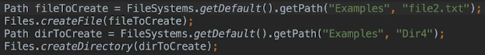  
* To create multiple directories or one that’s nested in non-existent directories, you can use:  
* **Files.createDirectories()**  
  
* **It creates any non-existent parent directories**.

* Windows path would be:  
  
* **Another way to do it would be**:  
  
* Let’s now see how to get a file’s **attributes** (**metadata**) such as the file size, when it was last modified, whether a path points to a file or a directory, etc.  
1) **Using the Files class you can get the value of a single attribute**.  
2) **Alternatively, you can retrieve all the attributes at once**.  
* **Files.size()**  
  
* **Files.getLastModifiedTime()**  
  
* **Files.creationTime()**\* **Files.isDirectory()**\* **Files.isRegularFile()**  
* **To get all the attributes in one shot, you’ll retrieve an instance of a class that implements an interface containing methods that can retrieve each individual attribute**.  
* It’s actually the **BasicFileAttributes** interface that covers a basic set of attributes that are common to all operating systems.  
* **File.readAttributes()**  
* **BasicFileAttributes.class**  
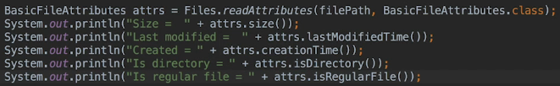  
* The Files.readAttributes() method returns an instance that implements the BasicFileAttributes interface and you have to pass BasicFileAttributes.class because there are system-specific sub-interfaces of BasicFileAttributes in the java.nio package that can also be retrieved using this method.

**Read Existing Directory Contents**  
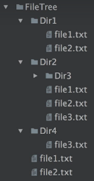  
* **DirectoryStream<Path>**  
* **Files.newDirectoryStream()** => returns a stream which needs to be closed once it’s finished.  
* We’ll use TRY-with-resources to do that.  
* The Files.newDirectoryStream returns a DirectoryStream of Paths.  
* **DirectoryStream** is an interface that implements the **Iterable** interface, so consequently you can iterate over the returned Paths to get the contents of the Dir2 folder.

* **getFileName()**  
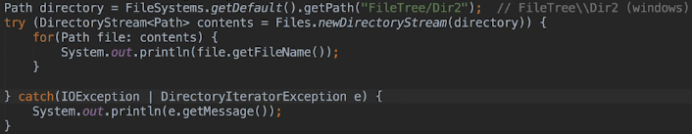  
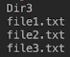  
* **Only the contents directly in the Dir2 directory are within the stream. So the method only returns the first level of content, also referred to as the directory’s direct descendants**.  
* When iterating over a DirectoryStream, a **DirectoryIteratorException** may be thrown, so it’s good practice to explicitly catch that and we can actually do thaat by using the **Pipe character |**. I’ts the **bitwise-inclusive OR**.  
* What if you only wanted to list or work on specific types of files in a directory?  
* The newDirectoryStream() method accepts a **filter (referred to as a GLOB)** as a 2nd parameter, and only Paths that match the filter will be included in the DirectoryStream.  
* A **glob** is a pattern that’s similar to a regular expression, but the syntax is more geared towards the types of things you’d wanna do when working with Paths.  
  
  
  
  
  
  
* **FileSystem.getPathMatcher()** => For the documentation on this.  
* Now, if the glob syntax isn’t sufficient for you to describe the Paths you wanna retrieve, you can also pass a regular expression, and therefore really take full advantage of the power that they offer.  
  
* **There’s an easier way to separate files and directories than using isDirectory() and isRegularFile().**  
* This time, a glob won’t help, because globs are used to match patterns against filenames so they don’t operate on file attributes, but there’s a **3rd version** of the **newDirectoryStream()** method that accepts a **DirectoryStream.Filter** parameter.  
* The DirectoryStream.Filter interface has only 1 method called **accept()** so that’s the method we have to implement.  
* When accept() returns true for a Path, the Path will be included in the DirectoryStream results.  
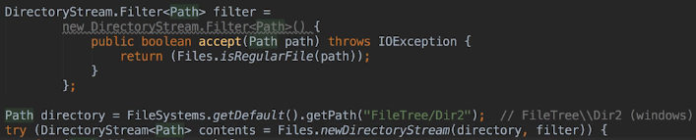  
* Since there’s only 1 method to implement, we could also have used a LAMBDA expression instead, let’s just quickly see how we could have done that as well.  


**Separators Temp Files and File Stores**  
* To find out whether the system where the application is running is using / or \ as a file separator, you can use  
1) **File.separator** constant => which is still commonly used  
2) **FileSystems.getDefault().getSeparator()** => another alternative.  
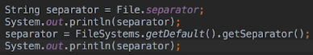  
* **It’s good practice to never hard-code the file separator**.  
  
* **For creating long paths, you’d probably use a StringBuilder**.  
* For learning purposes and simplicity, I’m gonna keep hard-coding it but in a real world application, make sure that you’re supporting all operating systems.  
* **How to create temporary files?**  
* **Files.createTempFile()** => creates a temporary file in the operating system’s default temporary file directory.  
=> 1st parameter = prefix  
=> 2nd parameter = suffix  
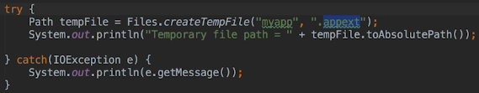  
  
* You can pass a 3rd parameter to specify the file attributes if you want to.  
* One thing to note, though, is that the resulting path name is always associated with the default file system. **If you wanna store the temp file somewhere else, you can do that by using another version of the createTempFile() method that accepts more parameters, including a parent directory path**.  
* There’s also a **Files.createTempDirectory()** method as well.  
* The other thing I wanna talk about is file stores - or what you might be think of as drives. On a UNIX system, each mounted system is a file store. On Windows, each drive or volume is a file store, for example the C: the C drive.  
* So how do we get the file stores?  
* **FileSystems.getFileStores() => returns an Iterable of FileStore**  
* **FileStore**  
* **Iterable<FileStore>**  
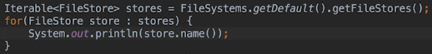  
* **FileSystems.getDefault() method actually returns a file system object. Some system can have more than one file system, and when you call getDefault(), you’re getting the default and often the only file system**.  
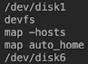

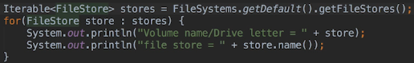  
* **On Windows, you’ll probably see the names of the volumes printed out, not the drive letters. And it’s probably more useful to get the drive letters. And there’s actually 2 ways to get them**.  
* Testing on my own Windows:  
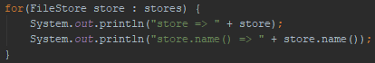   
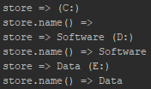  
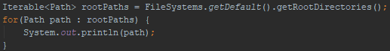  
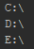  
* Back in video:  
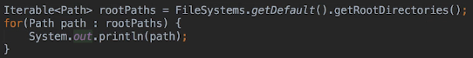  
* Drive letters for all available drives in the system will be printed whether you’re actually available or not. For example, if you had 4 USB ports but only 2 of them were occupied, drive letters for all 4 would still be printed.  
* The truth is, though, that you usually don’t need to get the root drives because, if you think about it, there aren’t many use cases for this and that’s because when an application is installed, it remembers or can find out where it lives on the file system. And if it then needs the user to tell it where to save files or where to load them from, the user will usually be presented with a dialogue and can then navigate to or type in the path.

**Walk File Tree**  
* By walking a file tree, what I mean is that we’re going to visit every file and directory that can be reached from a starting or root directory for that tree.  
* One use case for this might be when the application has to find a file.  
* Another use case could be that the application is searching all the files in the directory and below, for a specific stream.   
* I mentioned previously that when you want to copy a directory, you have to walk the file tree if you wanna copy everything below it as well.  
* Otherwise, any of the files directly within the directory itself will be copied.  
* Same thing when we were getting the contents of a directory - only the direct descendants are returned by default.  
* There are other use cases but these 2 are common ones that you might come across.

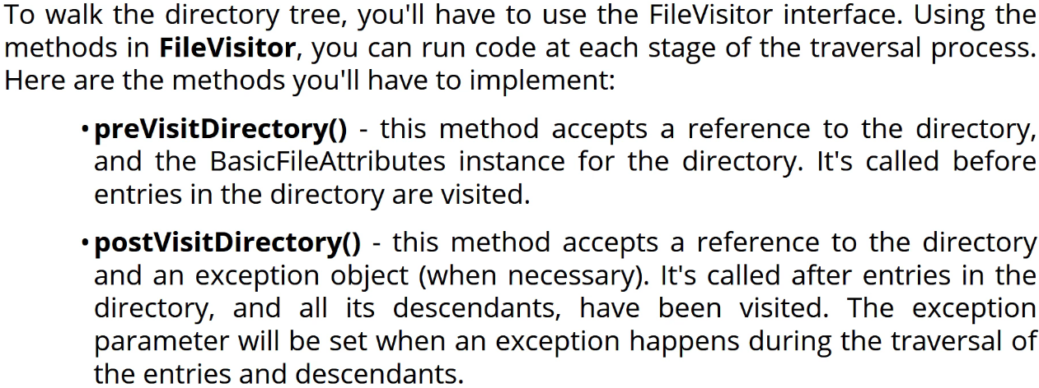  
* **FileVisitor** **interface**  
* **preVisitDirectory()**  
* **postVisitDirectory()**  
* **visitFile()**  
* **visitFileFailed()**  
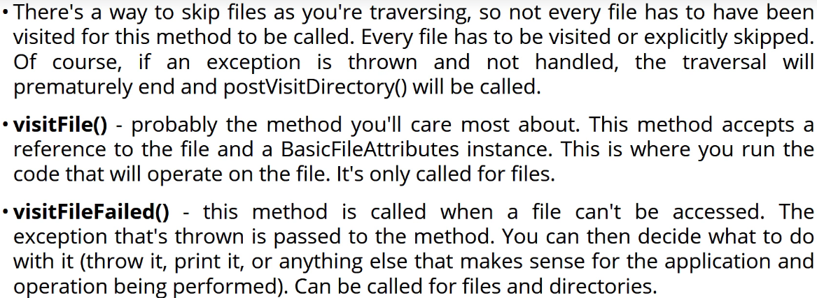  
* As with most interfaces like this, the JDK’s got an implementation that you can use called **SimpleFileVisitor**. You can extend this class and override just the methods that you require.

* **SimpleFileVisitor<Path>**  
* **FileVisitResult**  
* **FileVisitResult.CONTINUE**  
  
* Often, it’s a good idea to override the preVisitDirectory() and postVisitDirectory() so that you can print the name of the directories.  
* Notice that we’re specifying Path as the type of SimpleFileVisitor. This will also be the type of reference passed to the methods.  
* You can also return **SKIP_SIBLINGS** => which means the traversal should skip all the other entries in the same directory as the file. **If you return this from the preVisitDirectory(), then the directory itself is also skipped and the postVisitDirectory() method is never called for that directory. So basically in that scenario you’re saying that you want to completely ignore the directory and all its descendants and siblings**.  
* And **SKIP_SUBTREE** => use when you wanna skip a directory as well as terminate, which means that you want to stop the traversal. **Only makes sense to call this from the preVisitDirectory() method. Returning it from the other methods is equivalent to CONTINUE**.  
* For example, you’d return **TERMINATE** when you found the file that you’re searching for.  
* If we don’t implement the visitFileFailed() and an error occurs, then an IOException will be thrown. But, instead, you can notify the user or handle the error and then return CONTINUE if you want the traversal to actually continue on in the case of an error.  
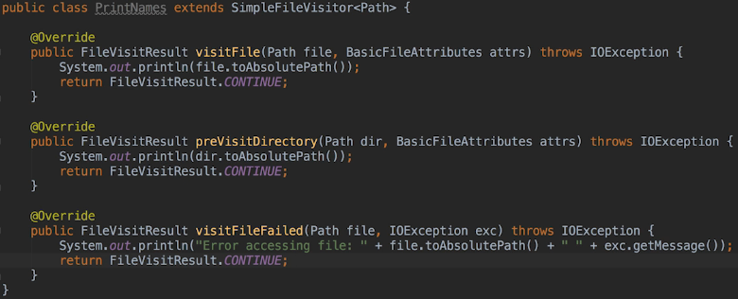  
* At this point now with our 3 overridden methods, we’ve got a working FileVisitor.  
* **Files.walkFileTree()**  
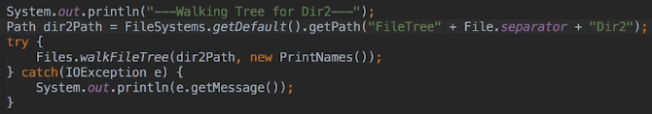  
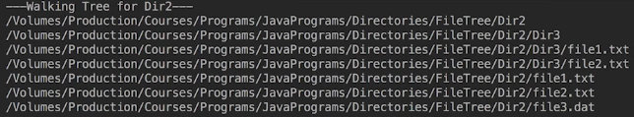  
* There’s actually a 2nd version of the walkFileTree() that accepts 4 parameters.  
* 3rd paramter => number of levels to traverse  
* 4th parameter => pass a set of fileVisit options  
* Right now the only option available is whether to follow symbolic links.  
* When you’re printing out the names, it doesn’t matter whether we use the preVisitDirectory() method to print directory names or the postVisitDirectory() method. **Depending on what you want to do, it can matter though**.

* **For example, if you wanted to copy a file tree, then you’d want to handle the directory before you handle those entries because the copy of the directory will have to exist before you can copy entries into it. So in the scenario, you’d actually handle the directory using the preVisitDirectory() method**.

* **On the other hand, if you wanted to traverse a file tree to delete it, then you’d actually want to handle the directory in the postVisitDirectory() method because you have to delete all the entries in the directory and all its descendants before you can delete the directory**.

* **One important note: you can’t make any assumptions about the order in which files and directories are visited, so you shouldn’t be making any assumptions with your code in that scenario**.

**Copy Entire Tree**  
* Let’s try to copy everything in the Dir2 directory to a Dir2 directory that’s within the Dir4 directory.  
* To do this, we wanna override the   
visitFile()  
visitFileFailed() => will be the same as for the print example  
preVisitDirectory()   
methods.  
* In order to figure out the path for the copied file, we’re gonna use the Path.relativize() method. This method constructs a relative path that resolves to a given path, for example with a path.relativize() against c:\path1 and the given path is c:\path1\path2\path3, then the relativized path would be \path2\path3 which is the given path relative to c:\path1.  
* Once we’ve got the relative path, we then need to resolve it against the copied directory’s location by calling the Path.resolve() method and that’ll turn the relative path we got from the relativize() method into the full path for the copied file.  
* **relativize()**  
* **resolve()**  
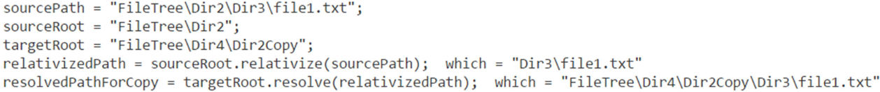  
* We’re essentially figuring out the relative path to the sourceRoot and then appending it to the targetRoot, because when doing a copy, the relative path to both the sourceRoot and targetRoot will be the same.  
* you need the source root path and the destination root path to figure out the path to figure out the path to copy, but the preVisitDirectory() method and the visitFile() methods are only passed to a reference to the directory or file that’s being visited. So you have to save the source and destination roots as instance variables in the CopyFiles class so consequently we’re gonna add those fields in the constructor to handle that.  
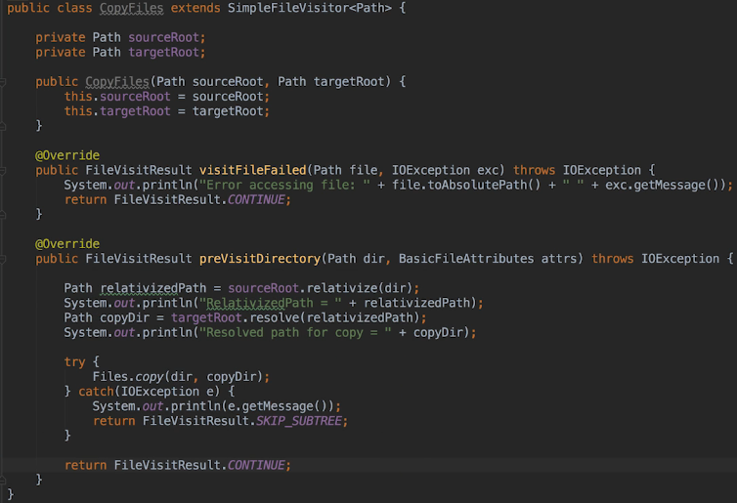

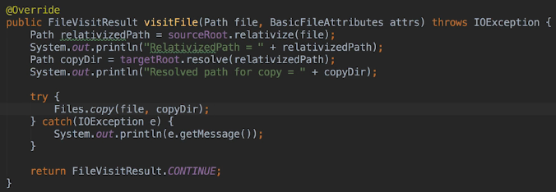  
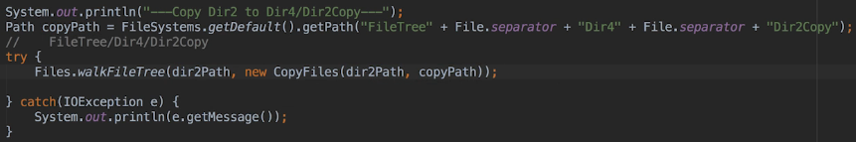  
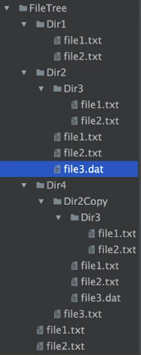  
* In a real world application you’d probably wanna beef up the code to handle situations for example like the destination file or directory already existing. What you could do perhaps is prompt the user and ask whether the existing file should be overwritten, for directories you’d then have to decide if it was an error when the directory you’re copying to already existed.  
* In addition you can pass more parameters to the copy method to specify what should happen if the destination path already exists.  
* In the next video we’re gonna be talking a little bit about mapping common java.IO operations to java.NIO.

**Mapping IO and NIO Methods**  
* We’ve learned quite a lot about using java.NIO with the file system.  
* Some developers still use java.IO and many existing Java applications, especially those written before java.NIO became available, still use java.IO.  
* In addition, many code examples around the web also use java.IO so it is very important that you’ll be able to read java.IO code and understand what it’s doing.  
* Let’s discuss how to map common java.IO operations to java.NIO.

* Let’s start with Paths.  
* **I mentioned that rather than using java.io.File, it’s better to use java.nio.Path**.  
* **Now you can use the File.toPath() method to convert an old style File instance to the preferred java.nio.Path instance**.   
* **toPath()**  
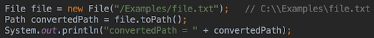  
* Note that it doesn’t matter whether the stream that we passed to the File constructor points to an existing file. Just like with Paths, the File doesn’t have to exist until the code tries to access it and even then, sometimes it’s okay if the file doesn’t exist, for example when opening a stream. If the file doesn’t exist, it’ll be created at that point.  
* **When it comes to the resolve() method that takes part of a path and resolves it relative to another path instance - you can do the same thing using the File class, but you have to do it when the file instance is created, using the version of the constructor that accepts the file and the string as parameters, or the constructor version that accepts two strings**.  
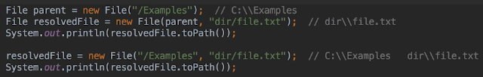  
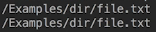  
* **Both are the same as**:  
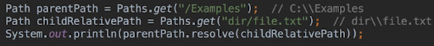  
* The equivalent methods in java.io File class to moving/renaming/deleting are:  
* **renameTo() java.io**  
* **delete() java.io**  
* In all the examples, we’ve used FileSystems.getDefault() to get the working directory, returns a path.  
* When working with many java.io methods, you actually need to use a file instance. Now there are several ways to do this, but some of them have drawbacks and that’s another reason why working with paths and the java.nio classes is better.  
* But here’s a hack that is more robust than a lot of other solutions:  
* **getAbsoluteFile() java.io**  
  
* TESTED MYSELF ON WINDOWS, all 3 of these do the same:  
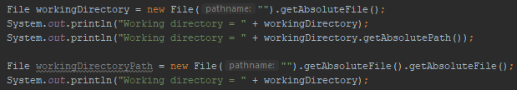  
* The reason it works is because when you pass an empty string to the file constructor, it actually translates it to the current directory for you and of course that’s the working directory for the application.

* **One major difference between java.io and java.nio is the way you list the contents of a directory**.  
* Previously in this section, you learned how to use a DirectoryStream when working with java.nio.  
* But when working with java.io, you use the file **list()** method and file **listFiles()** method. These methods do the same thing, but **the list() method returns an array of strings**   
and the **listFiles() method returns an array of Files**.  
* In addition, **you can pass an optional filtering parameter to the list()** method.  
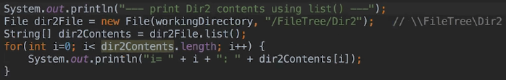  
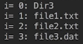  
* It doesn’t walk the tree down to any subfolders.  
* This gives us the same result:  
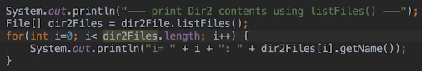  
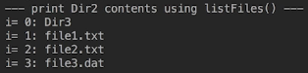  
* The only real difference there is the **getName()** method. When we print the files, that returns the last segment to the file path, which in this case is the filename.  
* Now, I discussed previously how to get a systems root drives or file stores and how it can be problematic.  
* You can actually use the file listRoots() method to get the roots but it has the same problem as the FileSystems.getRootDirectories() method. So it lists drive letters for drives that actually aren’t available.  
* There are many more java.io VS java.nio operations, but the differences are straightforward in thata the method names are usually a close match.  
* You should now know enough to be able to read code that accesses and modifies the file system using java.io and java.nio methods.  
=> **If you can take away only 1 thing from this section, it’s to use java.NIO when working with a FILE SYSTEM**.  
=> **But when it comes to reading and writing file contents, sometimes java.IO streams are still the better choice**.  
* You should really run benchmarks and decide what’s best for your application though, but my advice is to do as I mentioned - use java NIO when working with a file system and when reading and writing file contents often the java IO streams are the better choice.

**Resources**  
The try-with-resources Statement  
<https://docs.oracle.com/javase/7/docs/technotes/guides/language/try-with-resources.html>   
Class Files  
<https://docs.oracle.com/javase/8/docs/api/java/nio/file/Files.html>  
Interface BasicFileAttributes  
<https://docs.oracle.com/javase/8/docs/api/java/nio/file/attribute/BasicFileAttributes.html>  
getPathMatcher  
<https://docs.oracle.com/javase/8/docs/api/java/nio/file/FileSystem.html#getPathMatcher-java.lang.String->